INSTALLATION INSTRUCTIONS

CF MOTO
U-FORCE 1000 XL
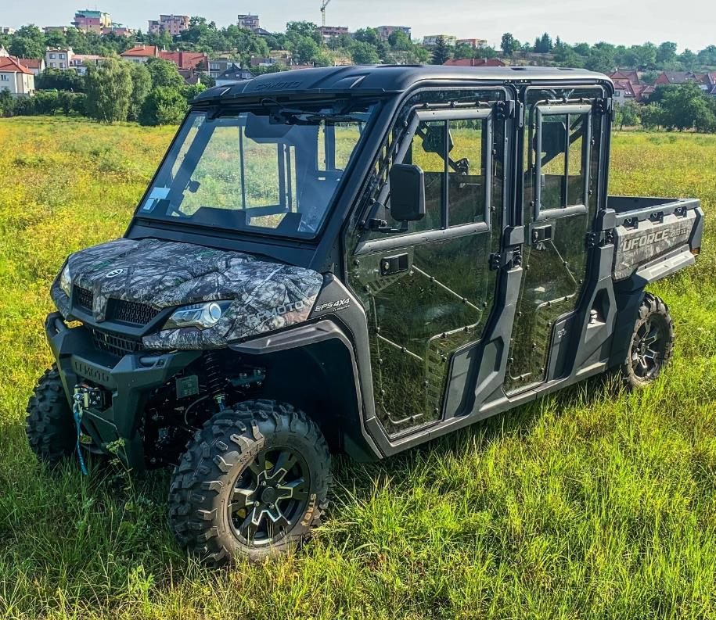
SAFETY INSTRUCTIONS

READ PROPERLY COMPLETE ASSEMBLY INSTRUCTIONS BEFORE STARTING OF ASSEMBLY

Warning: Failure to heed all safety and operating instructions and warnings regarding use of this product can result in serious bodily injury.

Install all parts indicated in assembly instructions. Failure to fully assemble product before use could result in personal injury.

Assembly of product requires use of hand or power tools. If you are not experienced in using these types of tools, have product dealer do the install for you.

Some parts contain sharp edges, wear protective gloves if necessary. Always keep your assembly area clean, uncluttered and well lit.

Keep visitors and children a safe distance away from the assembly area. Visitors should wear the same safety equipment described under.

Never operate your UTV with the cab doors open. Failure to properly latch the doors before moving the vehicle could result in serious injury.

Dress for safety. DO NOT wear loose clothing, gloves, neckties or jewelry if using power tools to assemble this product. Insert all nut covers after you finish installation.

Never drive your UTV with the cab front window in open position.

Failure of improperly latched/locked front window before driving the vehicle could result in serious injury.
MAINTENANCE AND CLEANING

To clean polycarbonate surface use soapy water solution or other subtle means.

Dirt and dust wash by gently water stream and swipe only with wet or damp means in the direction from top to bottom.

The recommended frequency of cleaning of polycarbonate part is about 1 time per month or according to the actual degree of pollution.

Do not use detergents that could scratch the surface plates (abrasives, harsh fabrics, etc.).

Do not use solvents or alkaline detergents or cleaners with ammonia (ammonium hydroxide).

Do not remove the impurities from the surface of the razor blades or other sharp items.

Do not clean cabin, when the polycarbonate plates are heated by the sun.

Do not use the squeegee. It could be scratched surface plates.

Do not clean the water current strength greater than 50 bar (WAP).

The manufacturer is not responsible for scratching the surface in case of failure to comply with the above instructions.

All bolted connections of cab must be checked and tightened by user at regular intervals.

It is necessary to check the air filter of the heater regularly, depending on the dust environment in which the vehicle is operated.
PREPARATION FOR INSTALLATION
Uninstall all additional systems from the roller cages (work lights, rear mirrors, door nets, drink holders etc.)

CAB PREVIEW
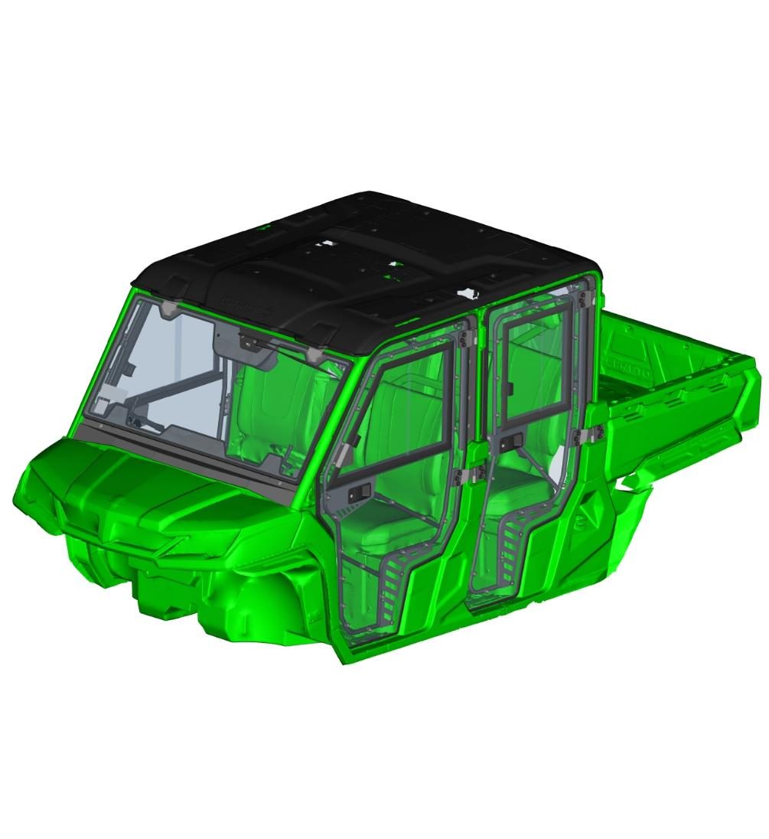

Uninstall the original plastic roof.

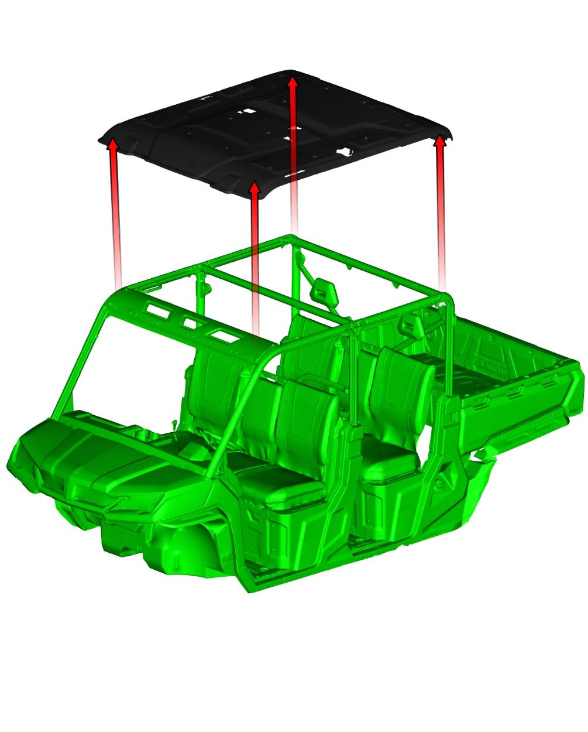
ELECTROINSTALLATION
HARNESS SCHEMATIC OVERALL DIAGRAM
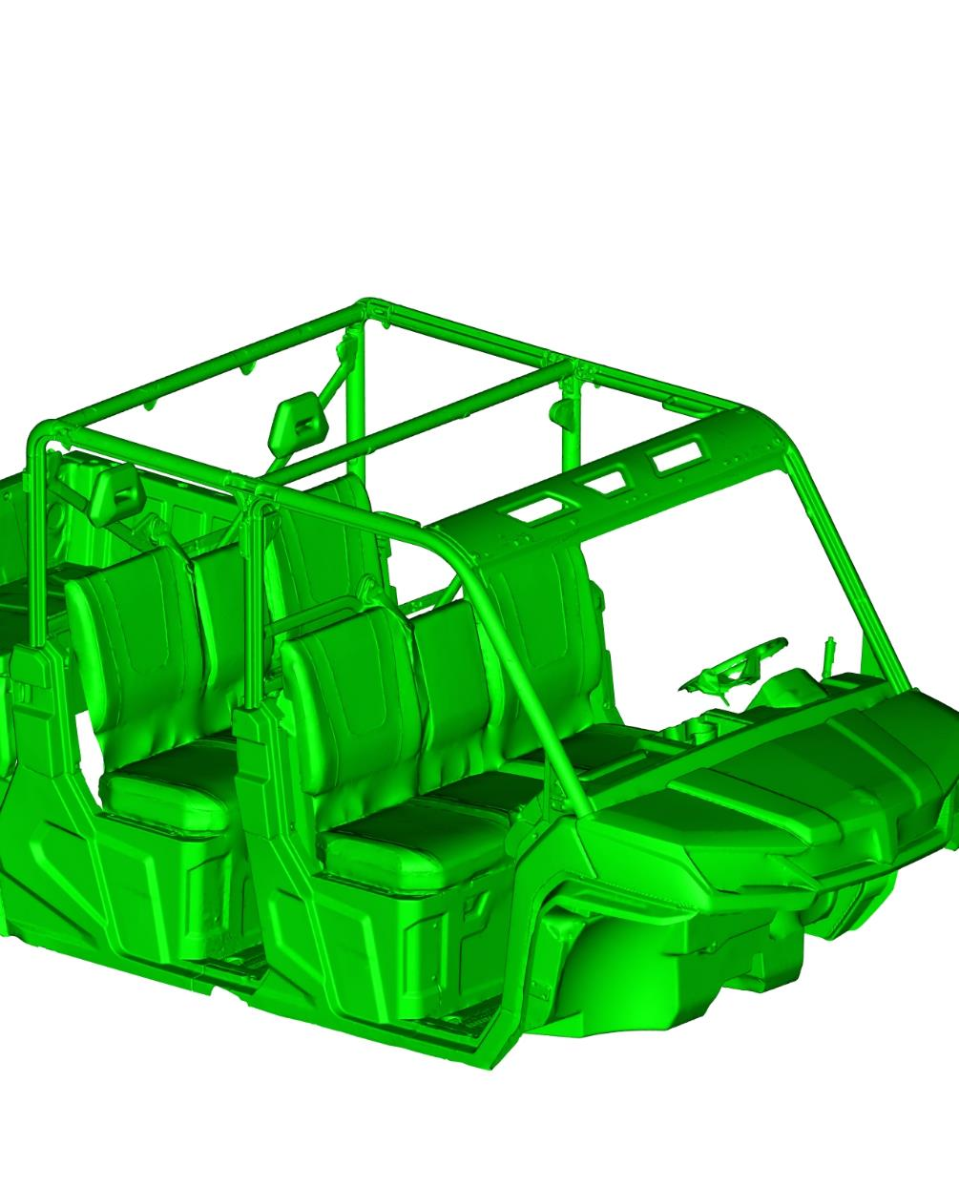
___ WIPER/WASHER HARNESS
___ HEATER HARNESS
___ EL. SUPPLY HARNESS
HEATER PUMP
WASHER TANK
VALVE SWITCH
VENTILATOR SWITCH
HEATER BODY
EL. MAG. VALVE
ORIGINAL EL. CONNECTOR
WIPER MOTOR
ELECTROINSTALLATION
Connection wiring diagram.
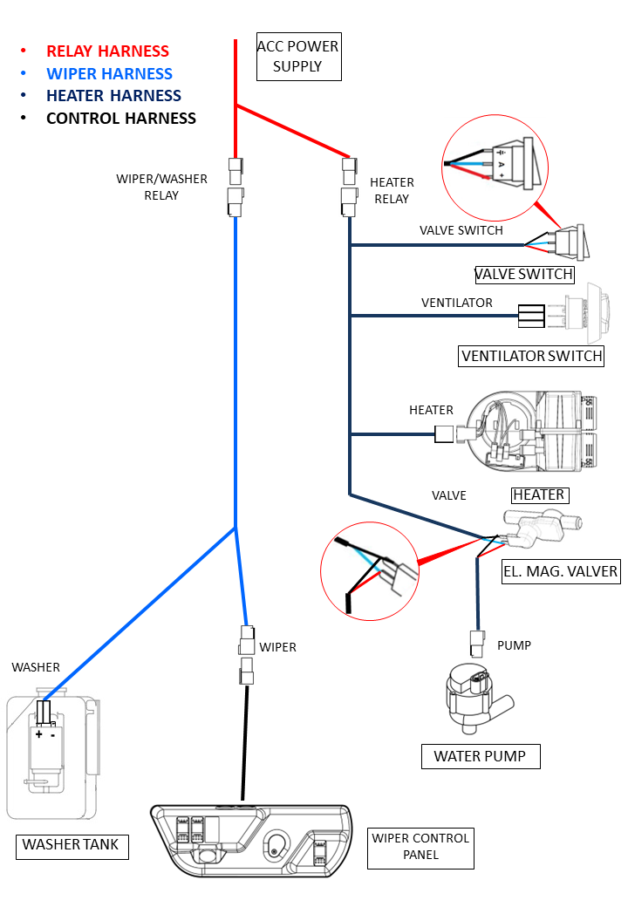
WIPER – WASHER 1
Uninstall front central hood.
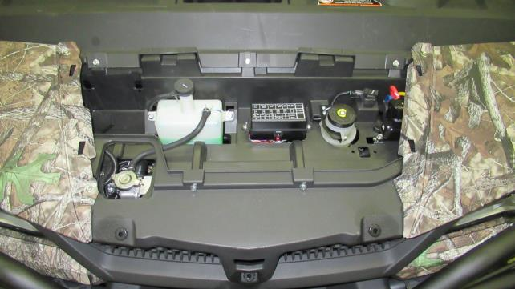
Uninstall front left hood.
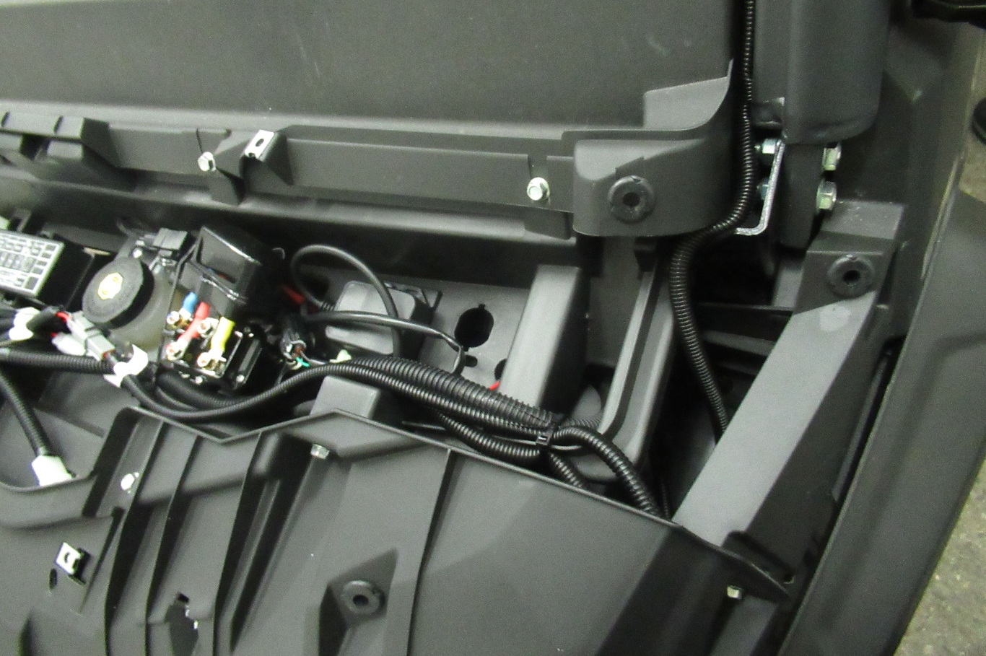
Uninstall dashboard compartment.
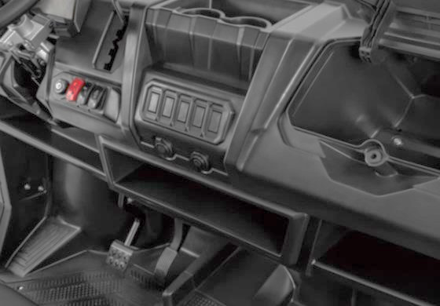
Place power supply harness under the central hood.
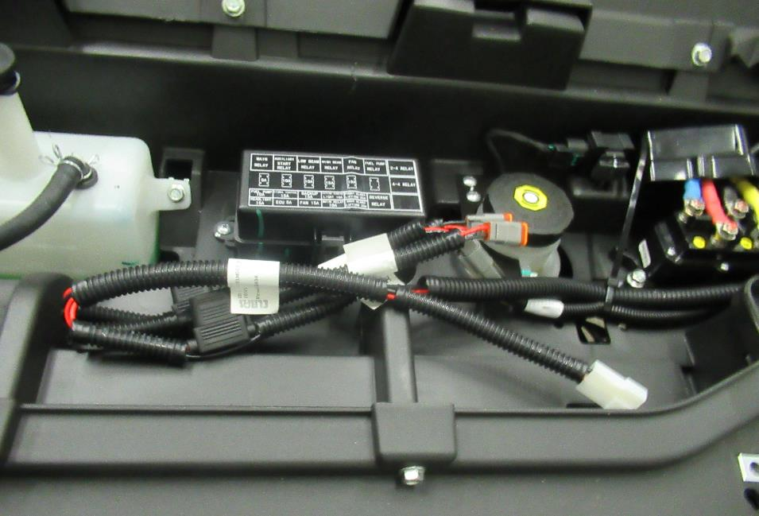
Uninstall plastic cover under the front right light.
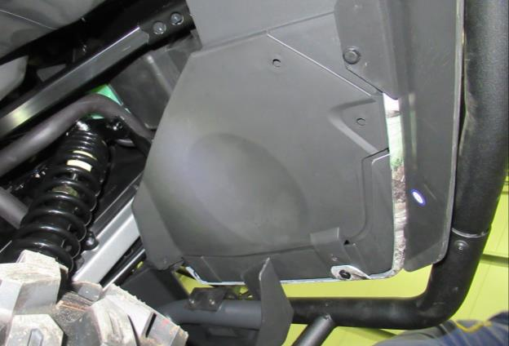
Unmount original power supply connector blank and measure polarity of pins.
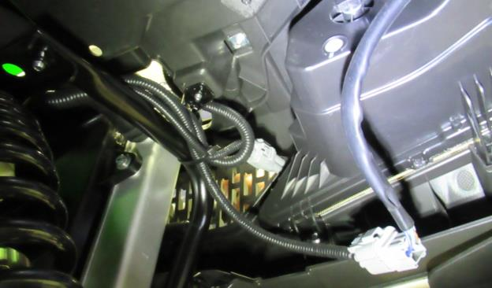
VIEW ONTO THE FRONT RIGHT LIGHT UNDER THE PLASTIC COVER FROM PREVIOUS PICTURE
Install power supply harness pins into the both power supply harness connectors with correct polarity.
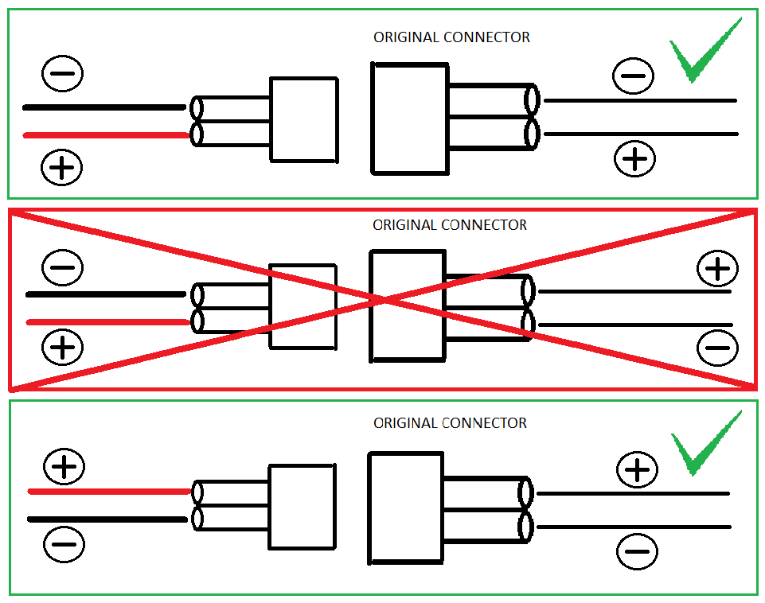
Connect power supply harness connector to the vehicle original power supply connector (red marked). Install connector blank on the other connector (green marked).
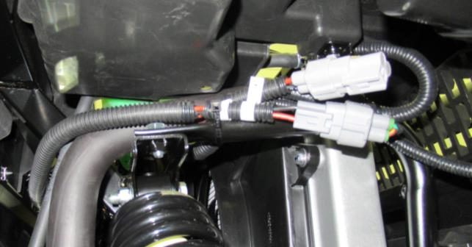
If you don’t have this connector on vehicle, use this harness and connect the cable eyes to battery. In the opposite case this harness doesn’t use a continue on next pages.
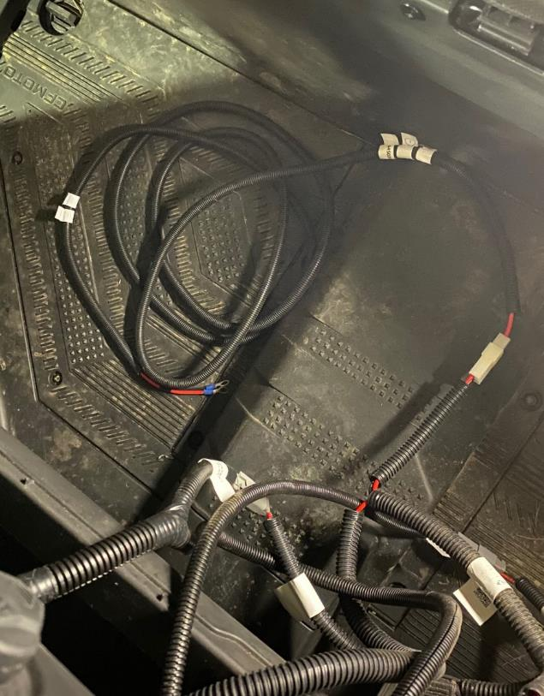
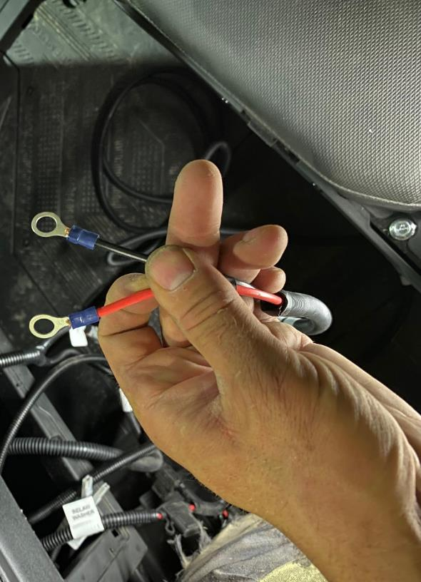
Install washer tank holder onto the vehicle frame by included bolt.
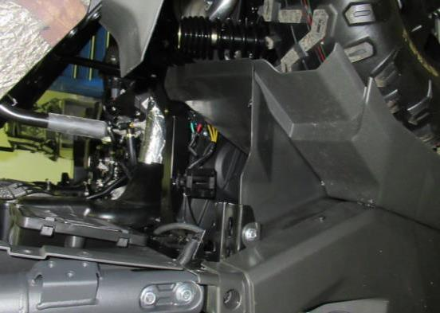
VIEW UNDER THE CARGO BED FROM THE LEFT SIDE
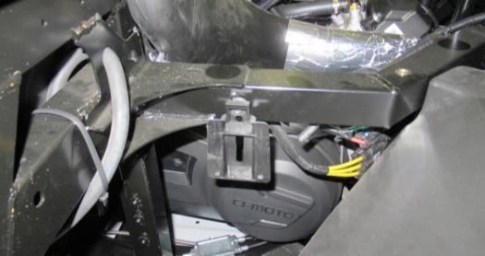
VIEW UNDER THE CARGO BED FROM THE LEFT SIDE
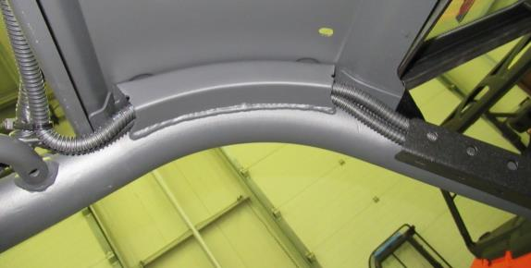
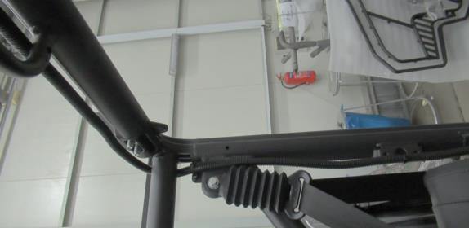
Wiper/washer harness routing. See next page.
TO THE WASHER TANK
WIPER/WASHER HARNESS
TO THE POWER SUPPLY HARNESS
TO THE WASHER TANK
TO THE WIPER MOTOR

Place the harness ledge onto the frame and fix by included bolt.
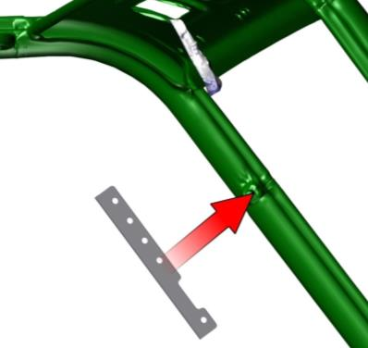
Install washer tank onto the holder. Connect washer harness connector and water hose to the washer tank motor.
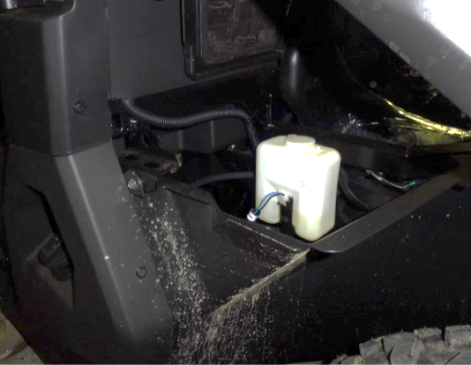
Route the wiper/washer harness between vehicle frame and dashboard under the hood.
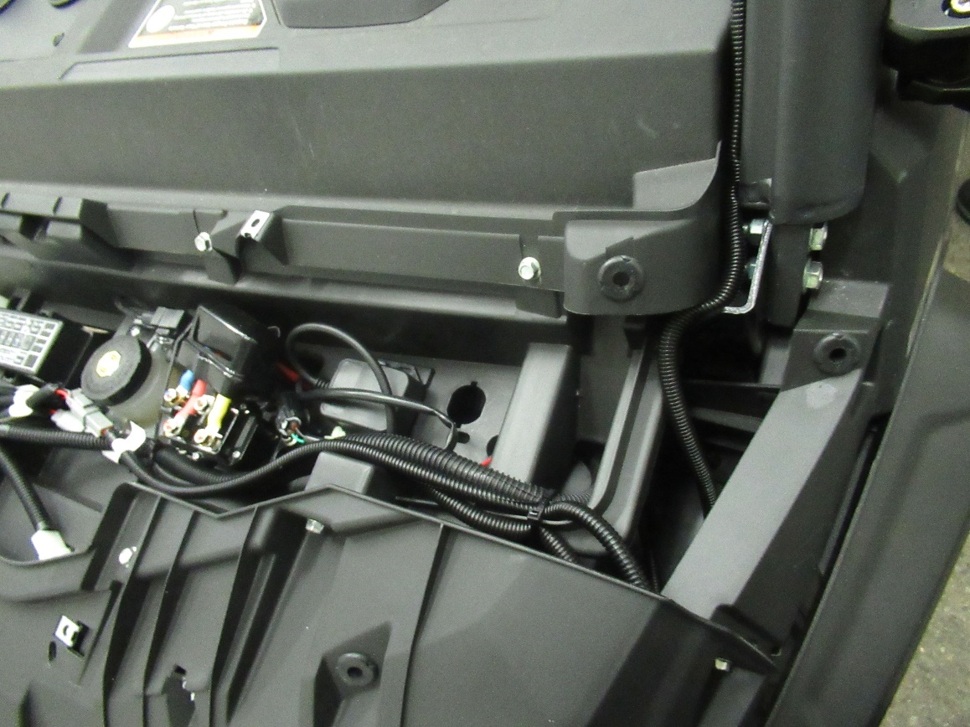

HEATER
Uninstall green marked drink holder.
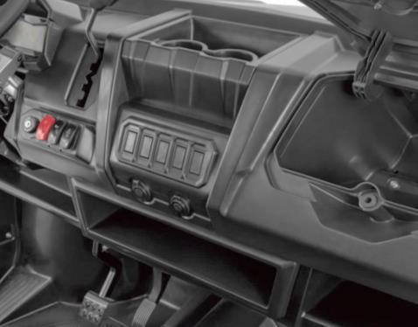
Drill 4 holes ø55mm (green marked) into the drink space bottom part.
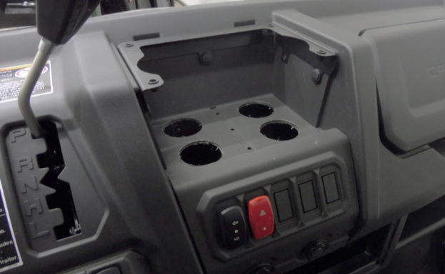
Place the heater holder onto the bottom dashboard part (behind the blue marked dashboard compartment). Mark 3 green marked holes onto the plastic wall and drill holes ø6mm. Drill 2 red marked holes ø25mm for a water hoses. Place the heater assembly onto the dashboard wall and fix by included fixing assembly.
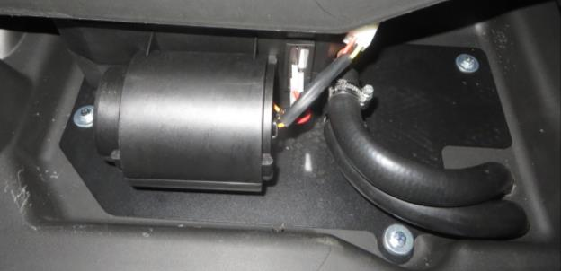
Stretch the air hoses, valve and ventilator switches connectors through the holes under the drink holder.
Place the U holder onto the dashboard. Mark 3 holes onto the walls and drill holes ø9mm.
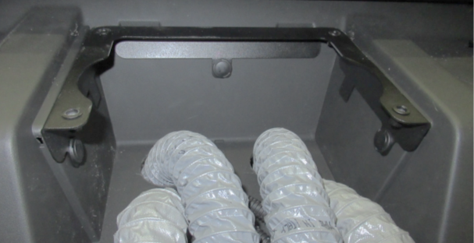
Place the U holder back and fix by included plastic rivets.
Connect valve and ventilator switch connectors of heater harness to the switches on the upper cover.
Stretch the air hoses through the cover holes and place it on the U holder.
Cut the air hoses about 10cm from the cover, fix them on the diffusers by tightening straps and insert them into the cover. Fix cover to the U holder by the fixing assembly.
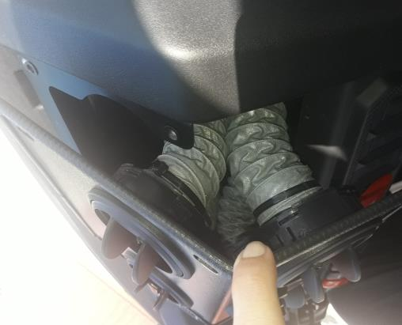

IMPORTANT!
IT IS NECESSARY TO UNMOUT RUBBER COVERS FROM HEATER WATER TUBES!
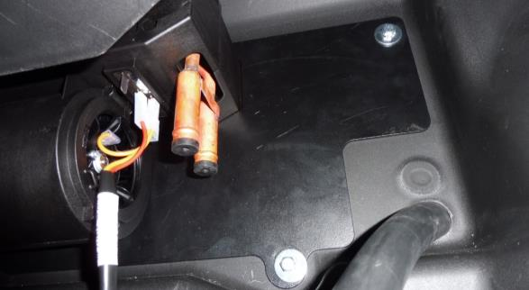
Stretch the water hoses through green marked holes. Place the tightening straps on the hoses, insert the hoses on the heater tubes and tighten straps.
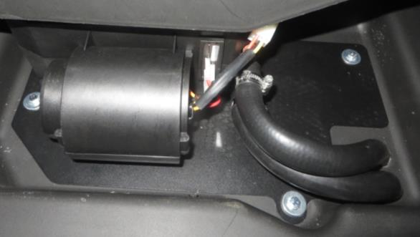

Route the wiper/washer harness to the power supply harness through el. harness bushing and connect to power supply harness.
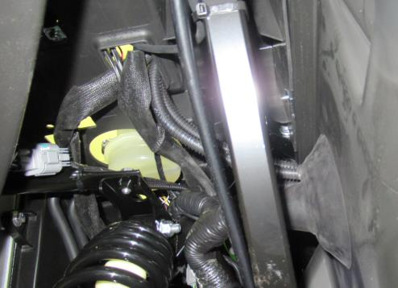
Connect the heater harness to the heater (red marked).
CAUTION
DO NOT MANIPULATE WITH ENGINE OR WITH ENGINE COOLING SYSTEM IF THAT PARTS OF MACHINE IS HOT! WHEN ENGINE IS HOT, ANY MANIPULATION CAN RESULT IN SERIOUS BODY INJURY!

Stretch the el. mag. valve harness branch through el. harness bushing and connect to the water pump harness. Connect el. harness to the water pump and el. mag. valve. It is strongly recommended to isolate connection on the el. mag. valve by isolating tape or similar system of isolation. Secure the vertical original hose (red line) by clamps. Cut the original hose and insert the tightening straps. Insert the „Y“ tube fitting connected with pump heater hose (green line). Tighten the straps hard.

It is very important to install tube fitting in correct orientation.
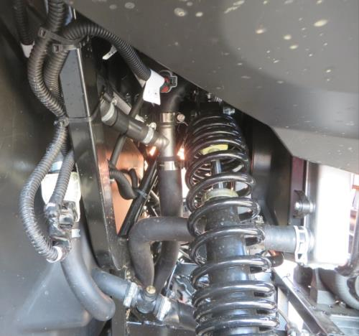
Secure the horizontal original hose (blue line) by clamps. Cut the original hose and insert the tightening straps. Insert the „Y“ tube fitting connected with air bleeding valve hose (yellow line). Tighten the straps hard.

It is very important to install tube in correct orientation.
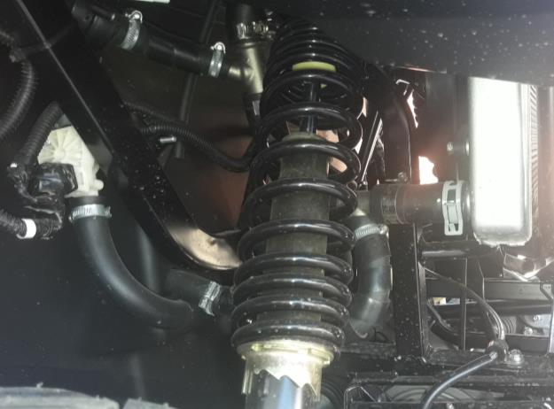
Connect the heater harness with the supply harness.

BLEEDING INSTRUCTIONS
- After installing the heater circuit, open the radiator and coolant reservoir of the vehicle. Fill coolant up to the MAX line in a both coolant reservoirs.
- Install coolant reservoir and radiator caps.
- Activate heater fan, turn on the electromagnetic valve and put the heating level to maximum.
- Run engine at idle with coolant reservoir cap ON until the cooling fan cycles two times.
- If a DFK bleeding valve is included in the heater assembly, open it at idle RPM until a continuous stream of air-free fluid flows out.
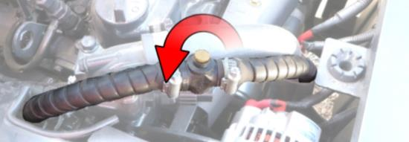
- Bleed even after the engine has warmed up to operating engine temperature and repeat several times until full flow, without air bubbles, escapes from the bleed plug holes.
- Check for heat coming out of the heater unit.
- Turn the ignition switch off and allow the engine to cool down.
- After the engine cools down check the coolant level in the radiator reserve tank.
- Close all coolant containers and bleeding valve before driving.
- After the test drive, check the coolant level in the radiator reserve tank and add coolant as necessary.
- Check for leaks in the entire heating circuit. Leaks can cause additional aeration.

FRONT PANEL
Place the front ledge onto the vehicle dashboard.
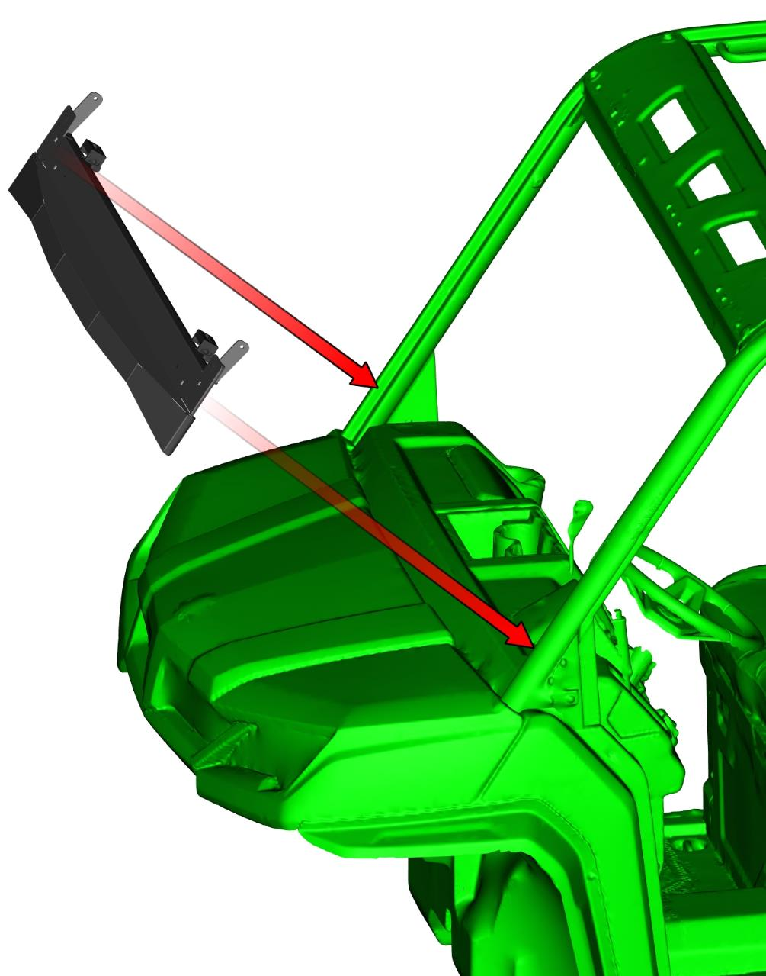
Place the front ledge holders onto the frame and onto the front ledge.
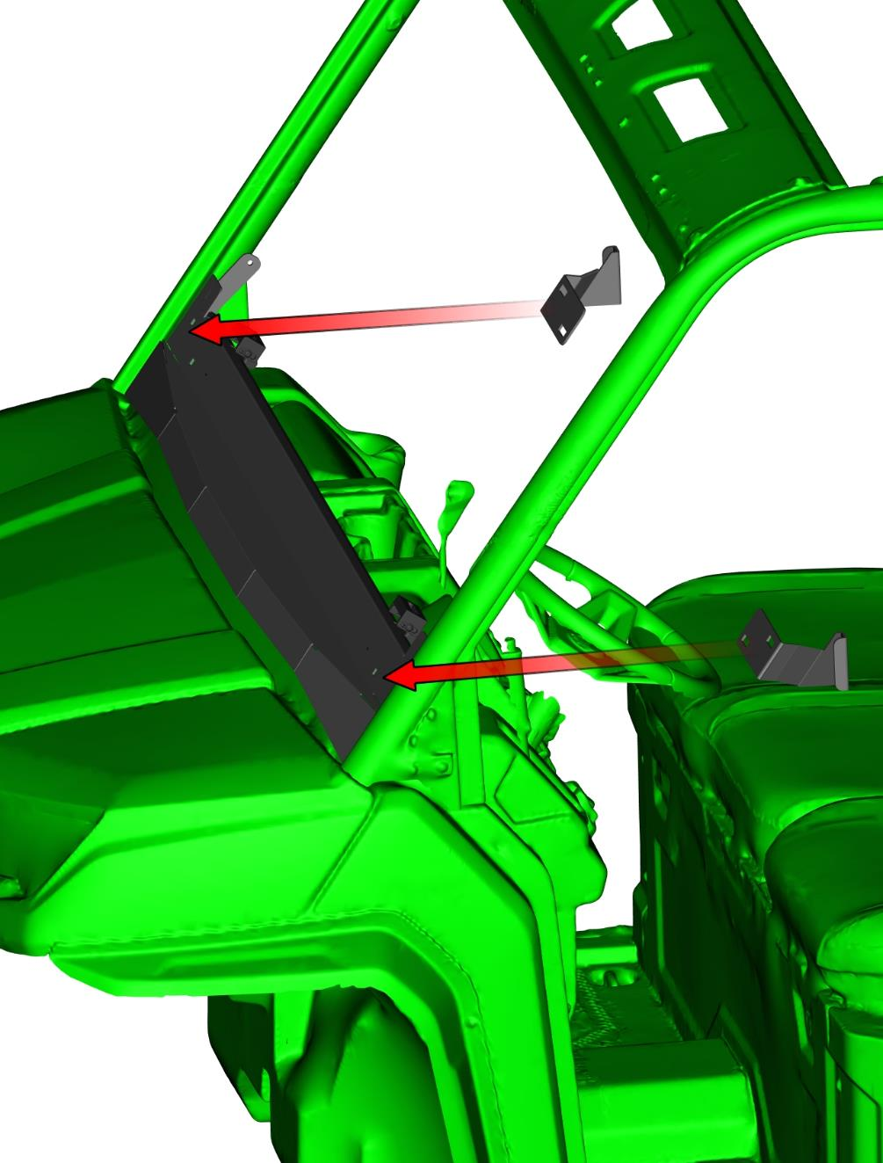
Prepare the front panel sealing stickers for application.

Degrease the surface of the vehicle frame where the sealing sticker will be affixed. Stick the sealing sticker on the vehicle frame as shown below.
Degrease the surface of the vehicle frame where the sealing sticker will be affixed. Stick the sealing sticker on the vehicle frame on the other side as shown below.

Fix the ledge holders by included bolts, washers, nuts and covers.
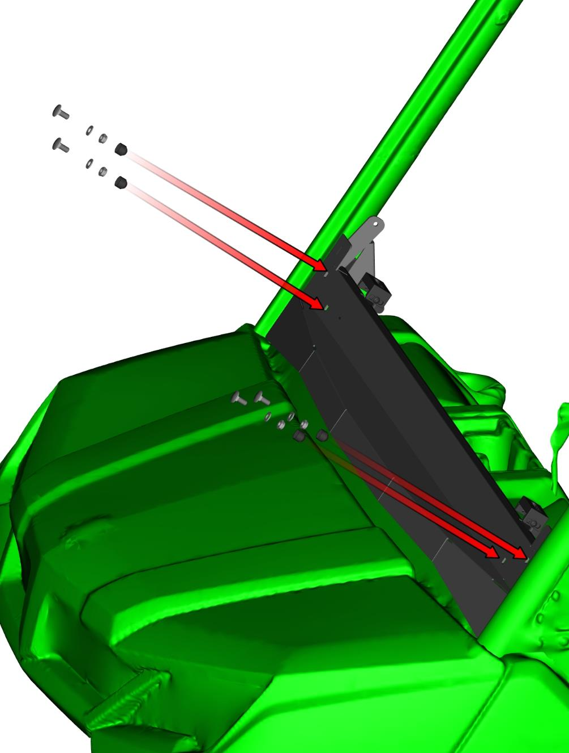
Place the front window assembly onto the vehicle frame and onto the front ledge.
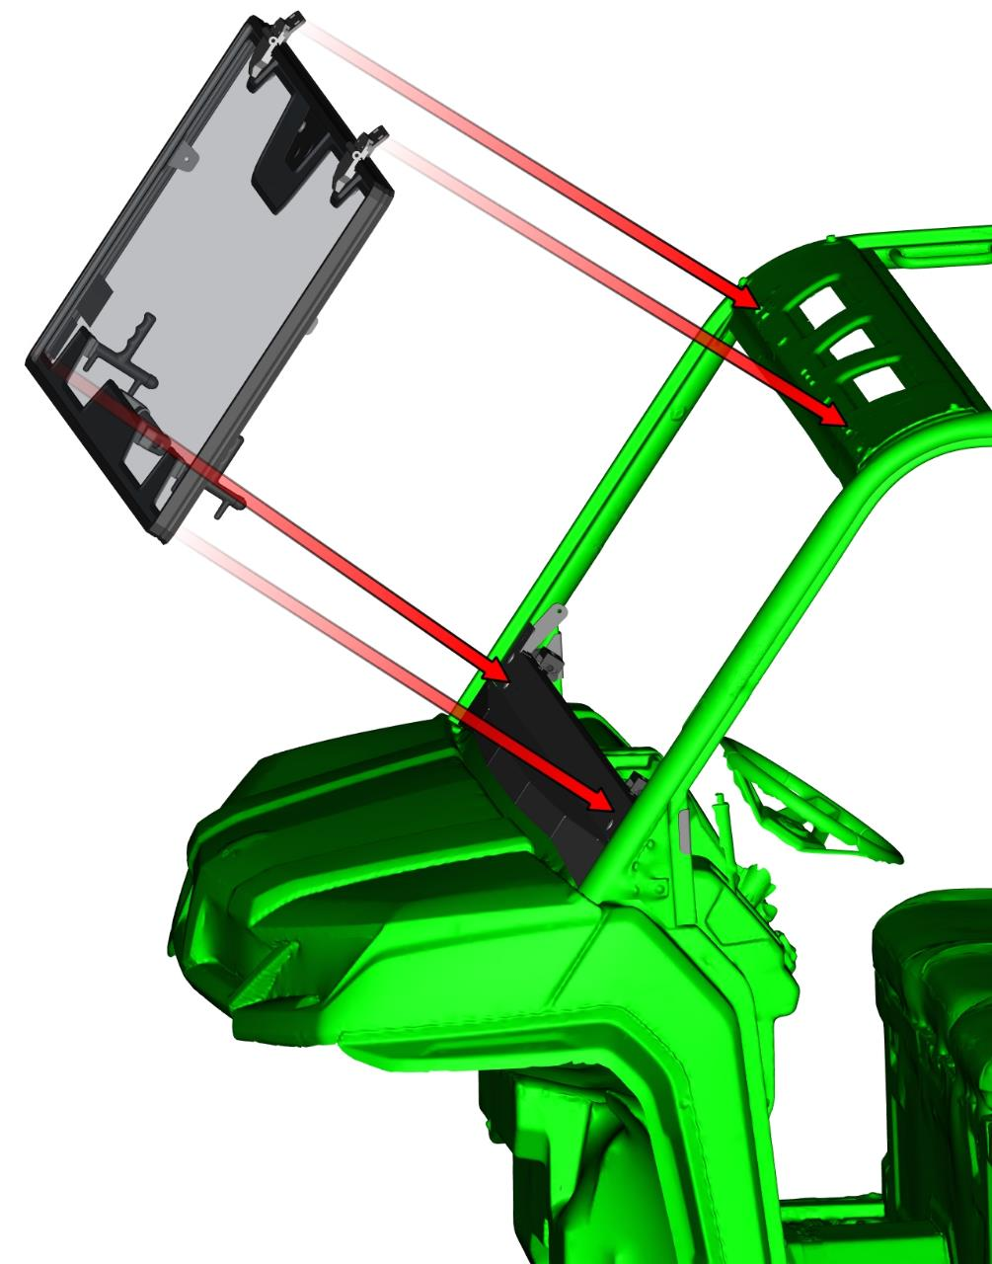
Fix the front window assembly hinges with the vehicle frame by included bolts, washers, nuts and covers.
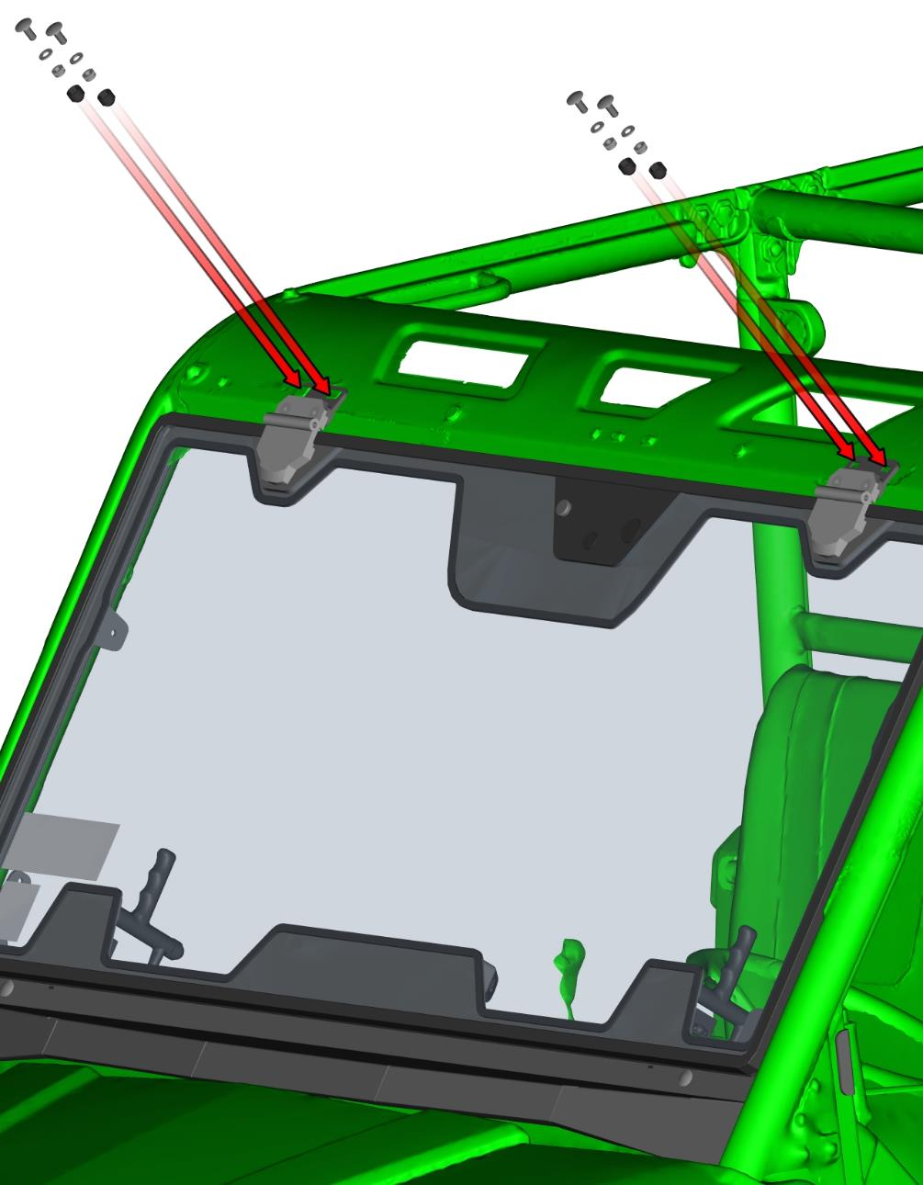
Install front gas spring pins into the gas spring holders and fix the gas spring pins by included nut, washer and cover. Repeat step on the other side. It is necessary to install gas spring in same orientation as on the picture.
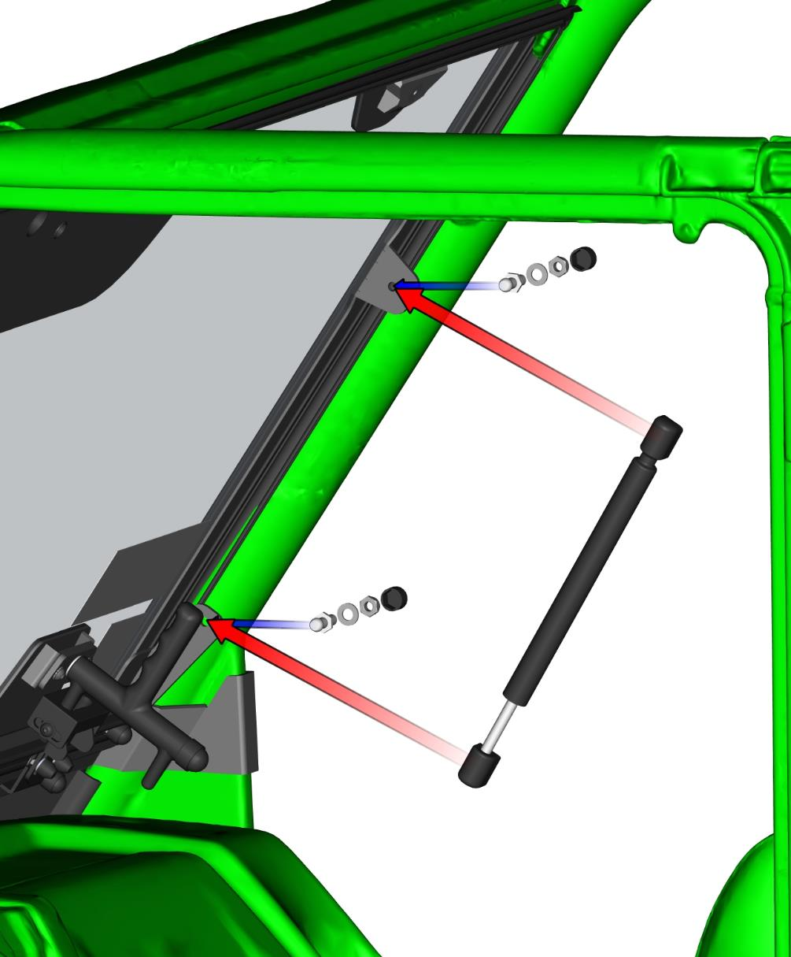
Place the wiper motor assembly on the windshield in accordance with the holes.
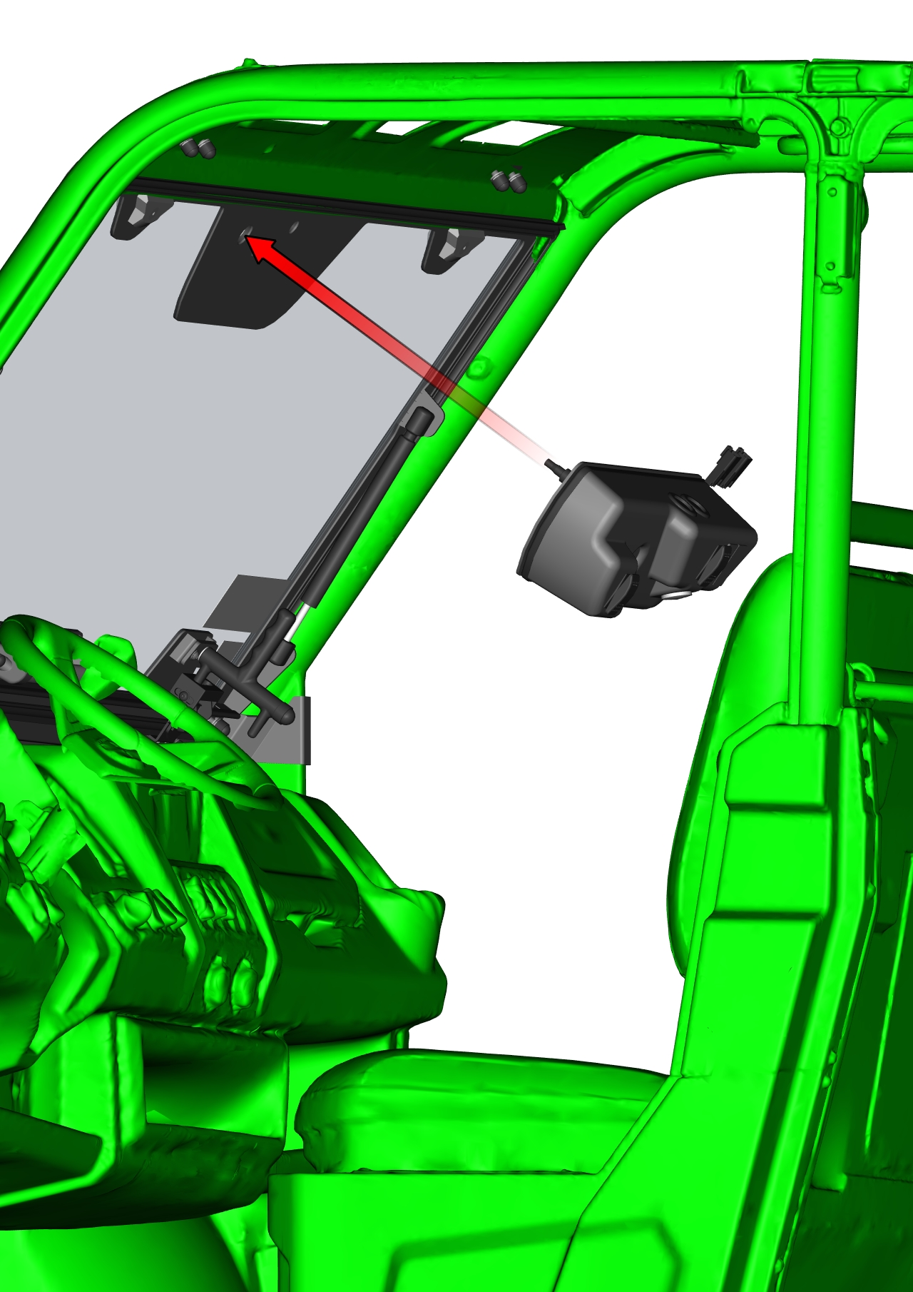
Fix the wiper motor assembly with included washers and nuts.
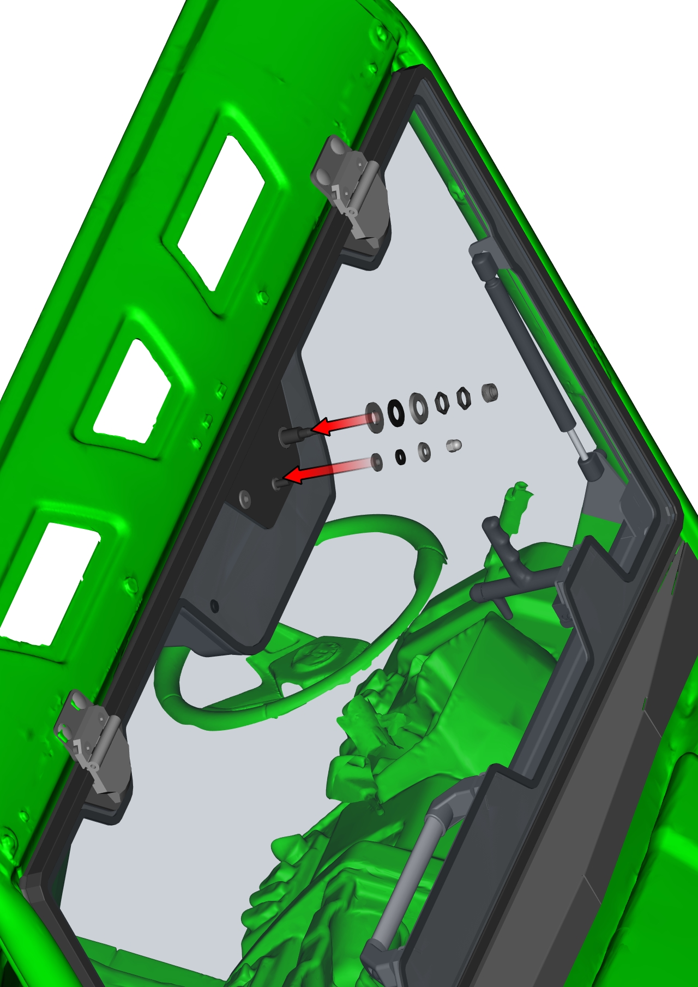
Install the wiper arm with wiper blade on the wiper motor rod. Fix the wiper arm with included nut.
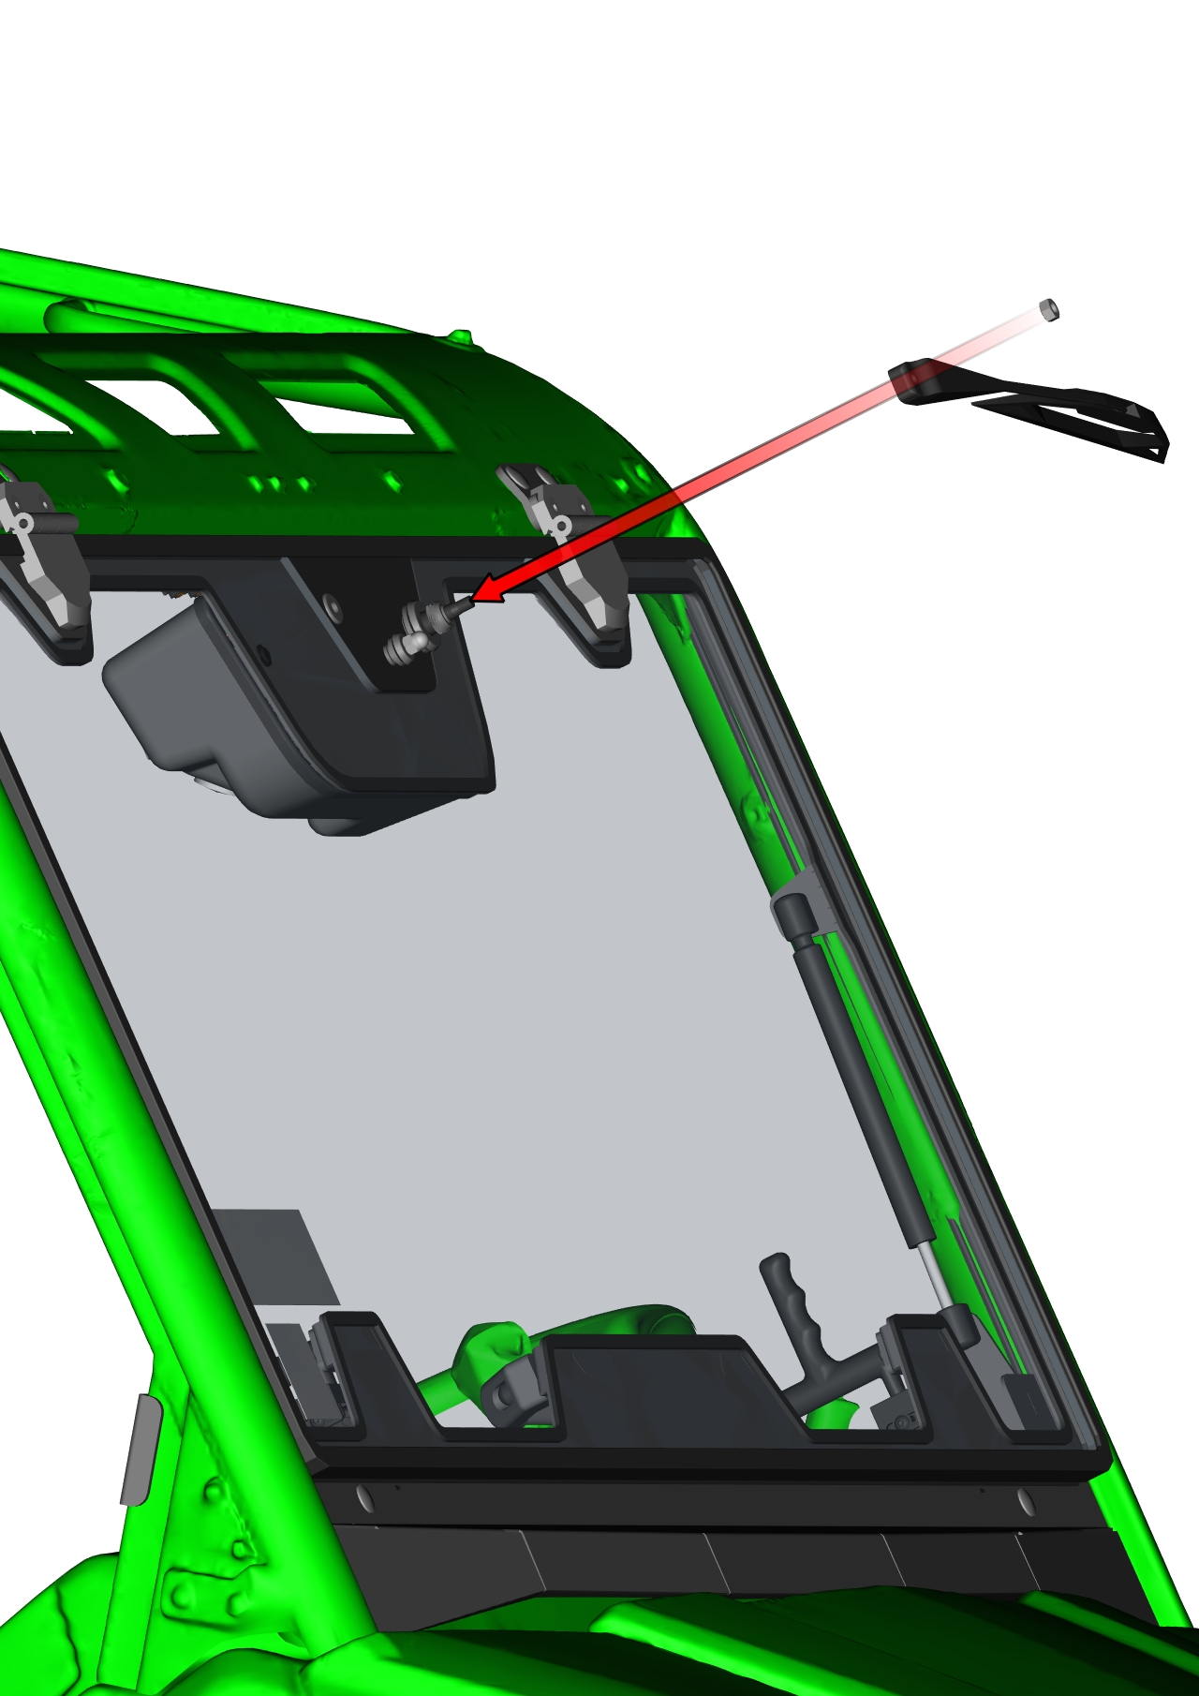
LEFT FRONT DOOR + RIGHT FRONT DOOR
Uninstall the plastic rivet nuts that hold the plastic cover. Remove the plastic cover (red dashed line) from the vehicle.
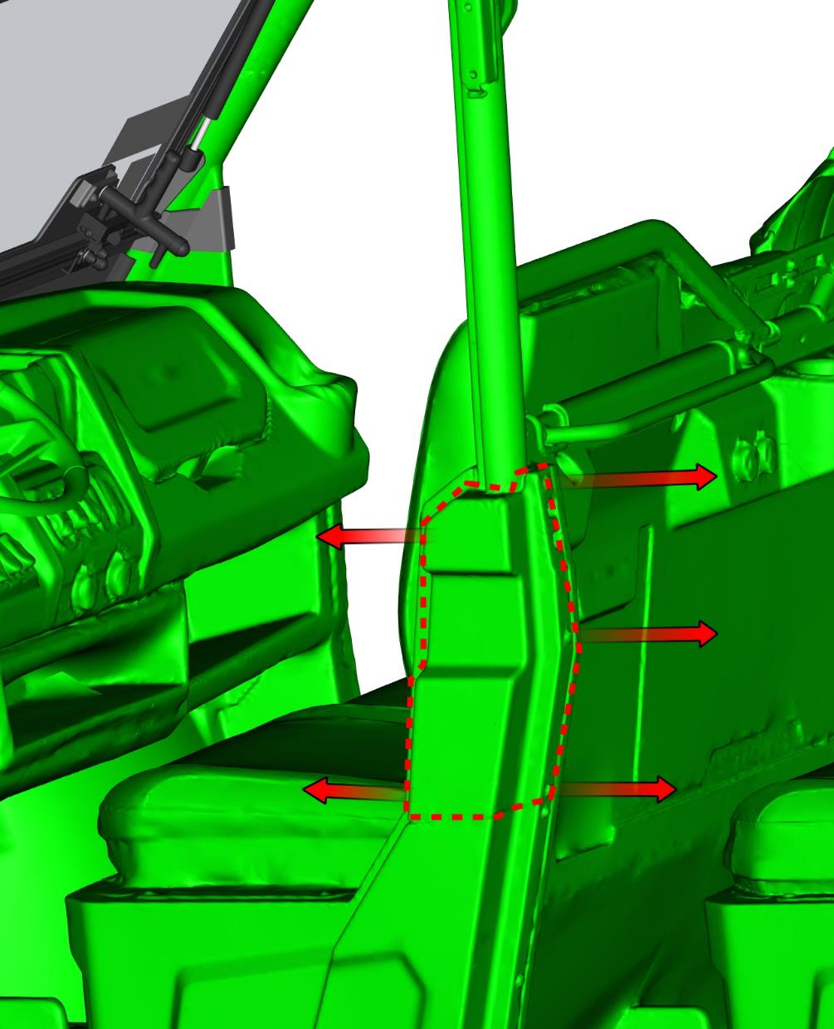
Cut a rectangular hole (65 x 40 mm) in the plastic cover for the door hinge.
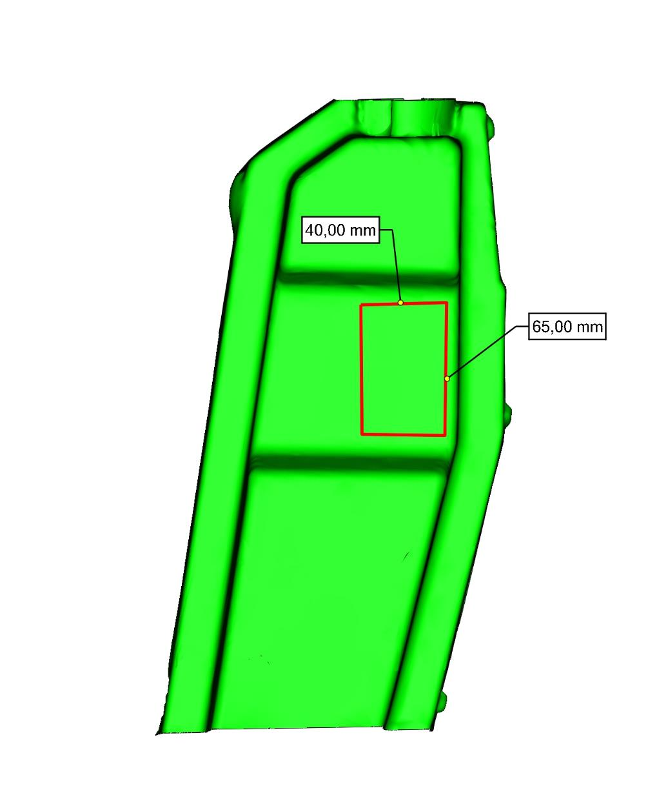

Place the front door bottom hinge holder and the rear door base on the vehicle frame.
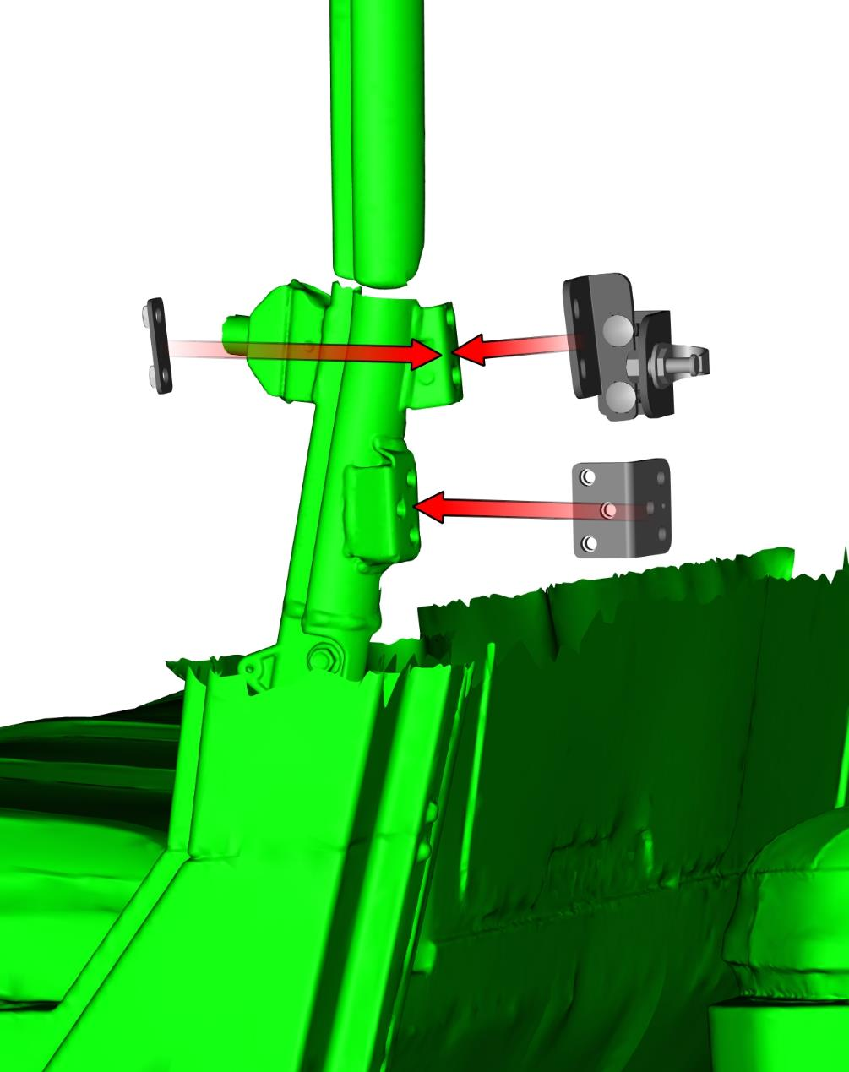
Fix the front door bottom hinge holder and the rear door base with included fixing assemblies.
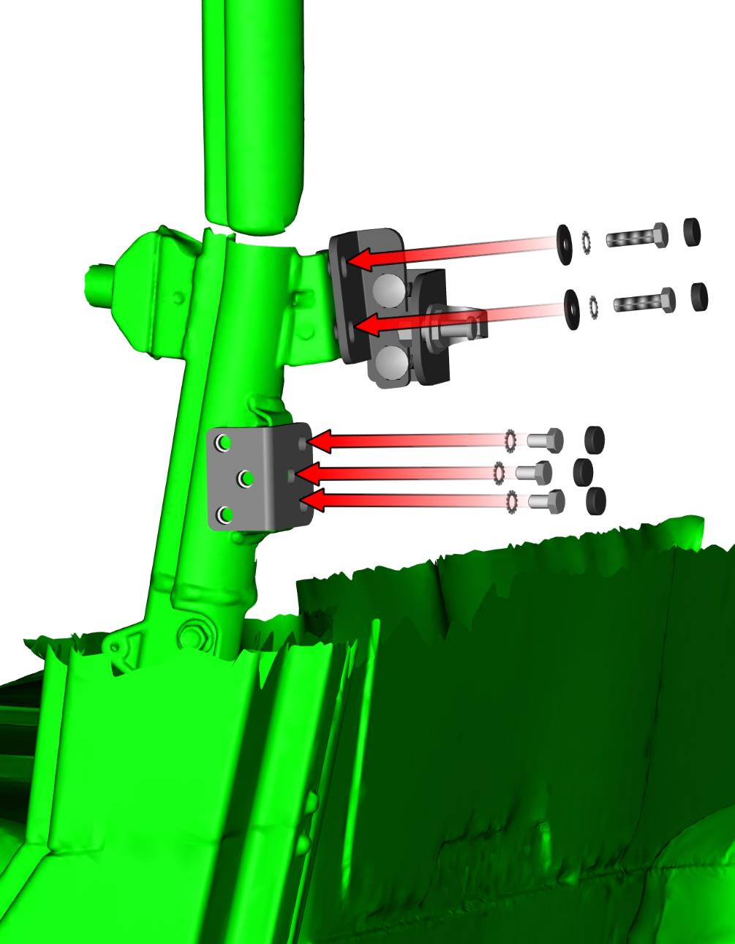
Do not tighten the rear door stop fixing screws yet.

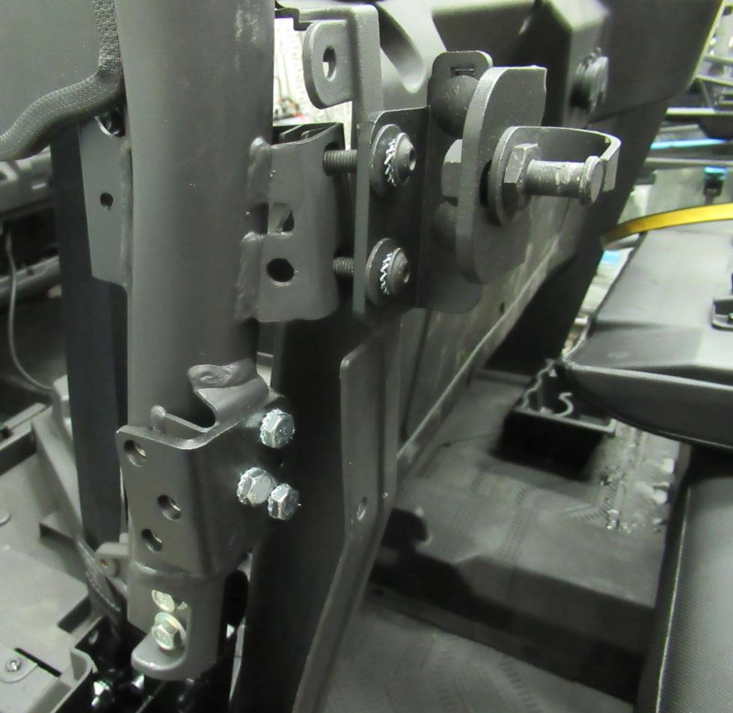

Install the plastic cover back to the original position. Fix the cover with original plastic rivet nuts. Then tighten the rear door stop fixing screws.
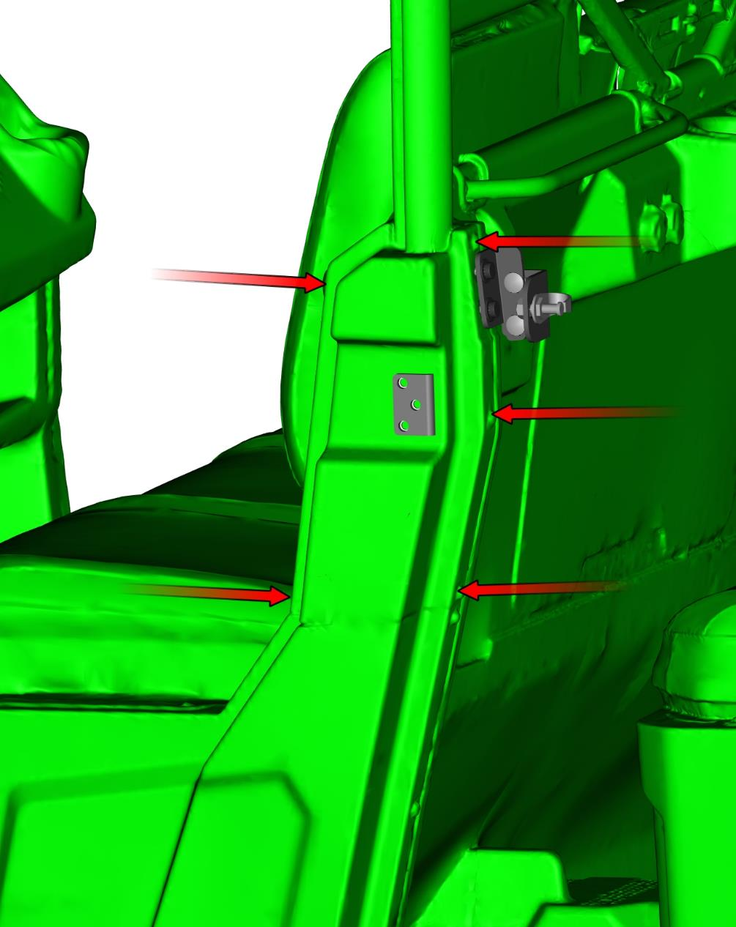
Place the front bottom hinge on the prepared hinge holder.
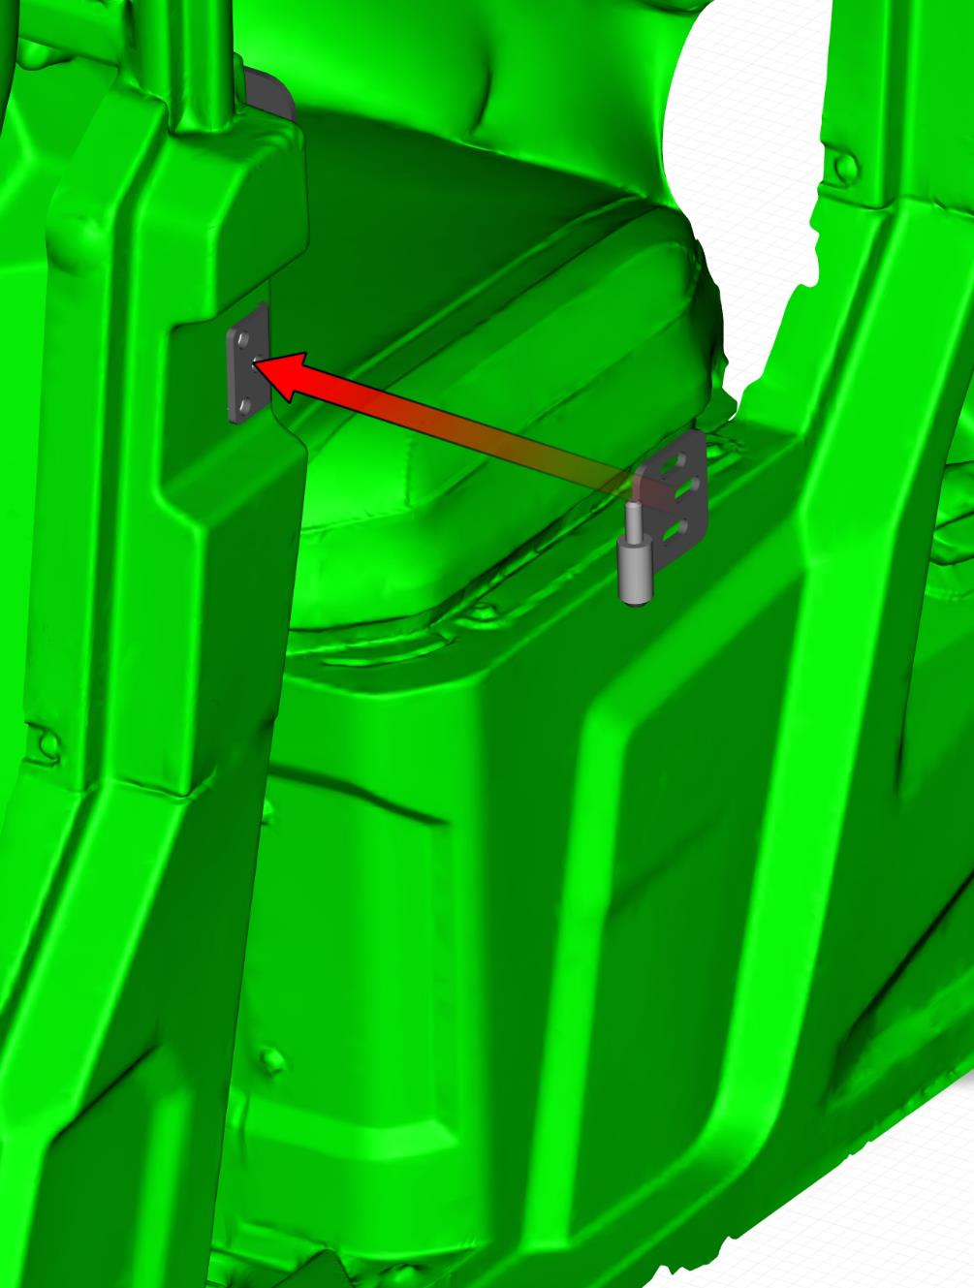
Fix the front door bottom hinge with included fixing assemblies.
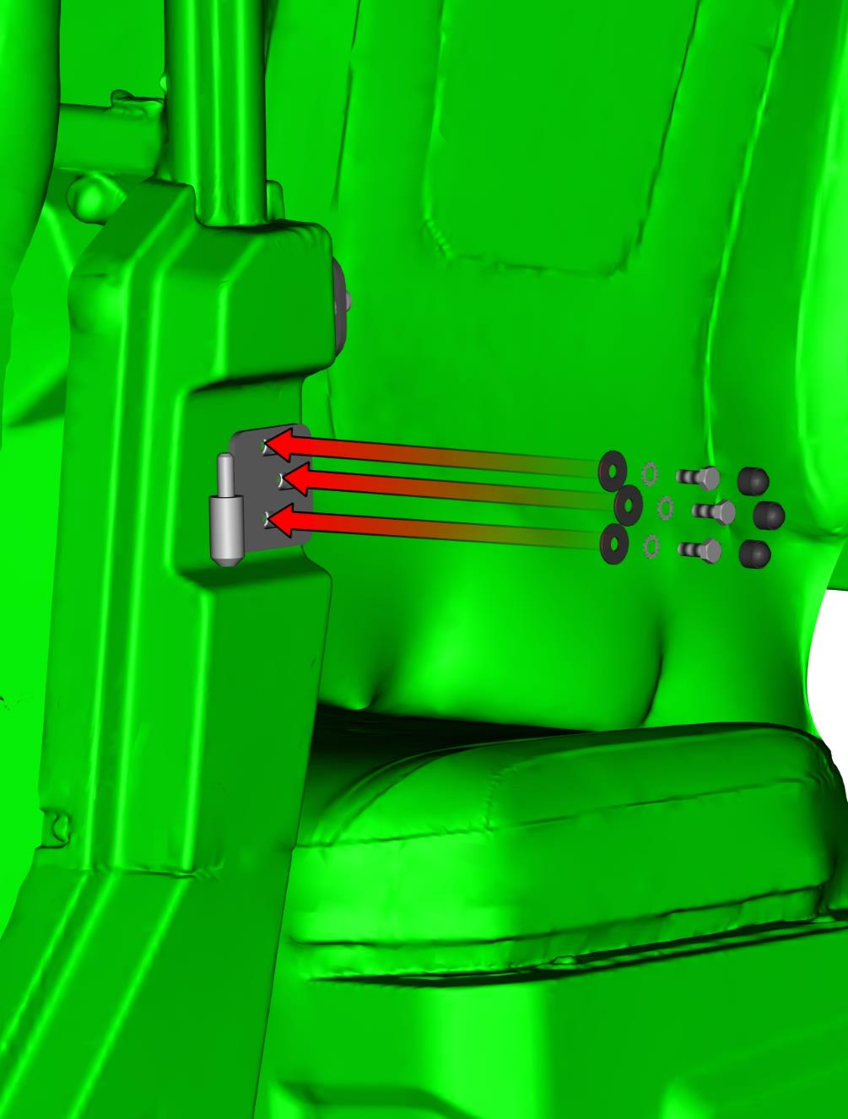
Remove the front door base holder from the front door base assembly.
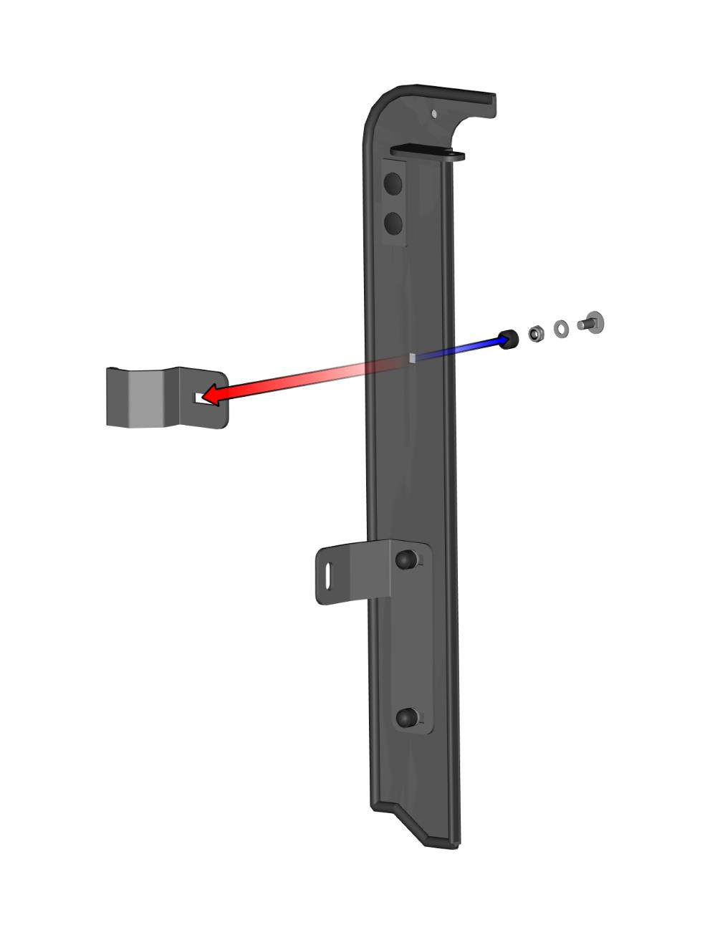
Place the front door base assembly on the vehicle frame.
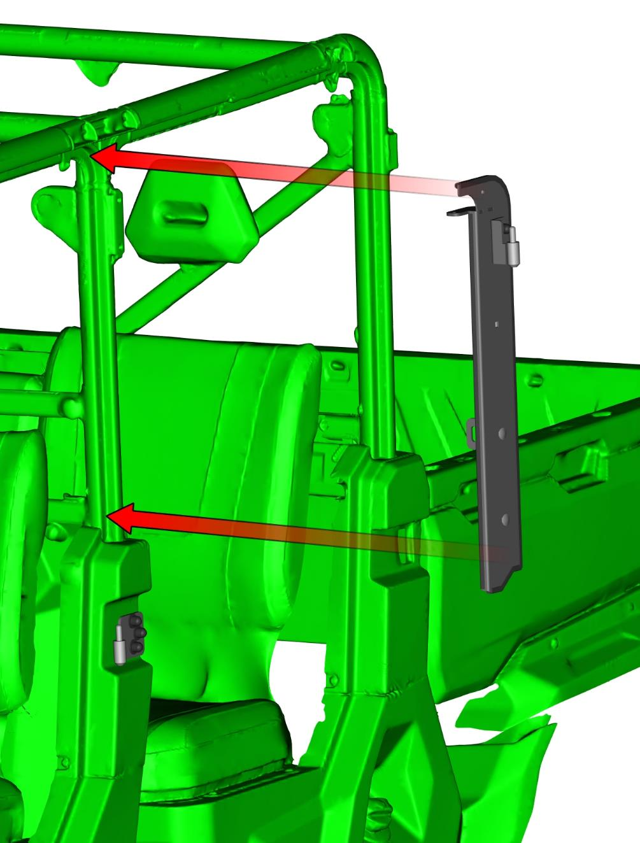
Fix the front door base with included fixing assemblies.
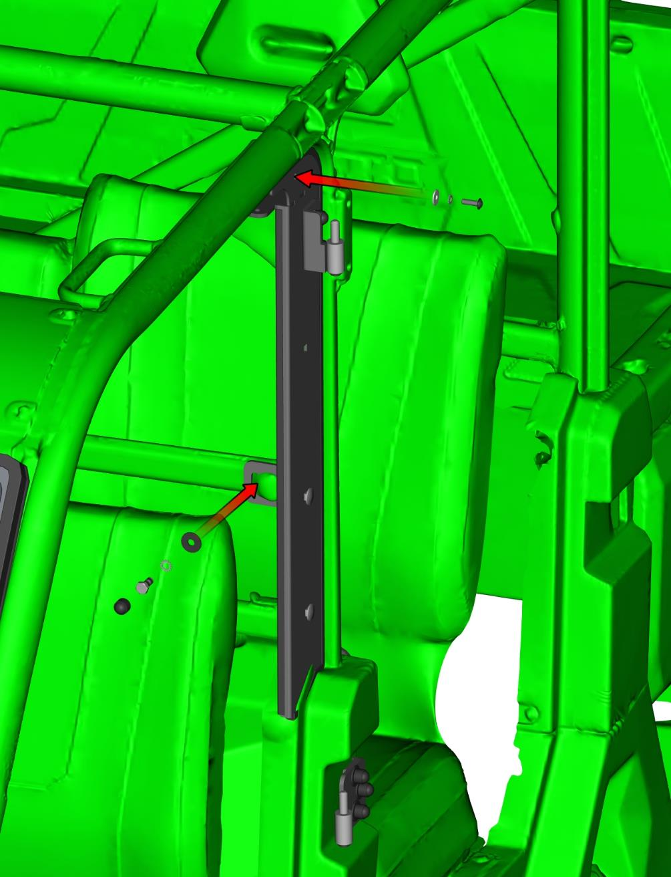
Place the front door base upper holder onto the front door base and onto the vehicle frame. Fix the holder on the base by included bolt, washer, nut and cover.
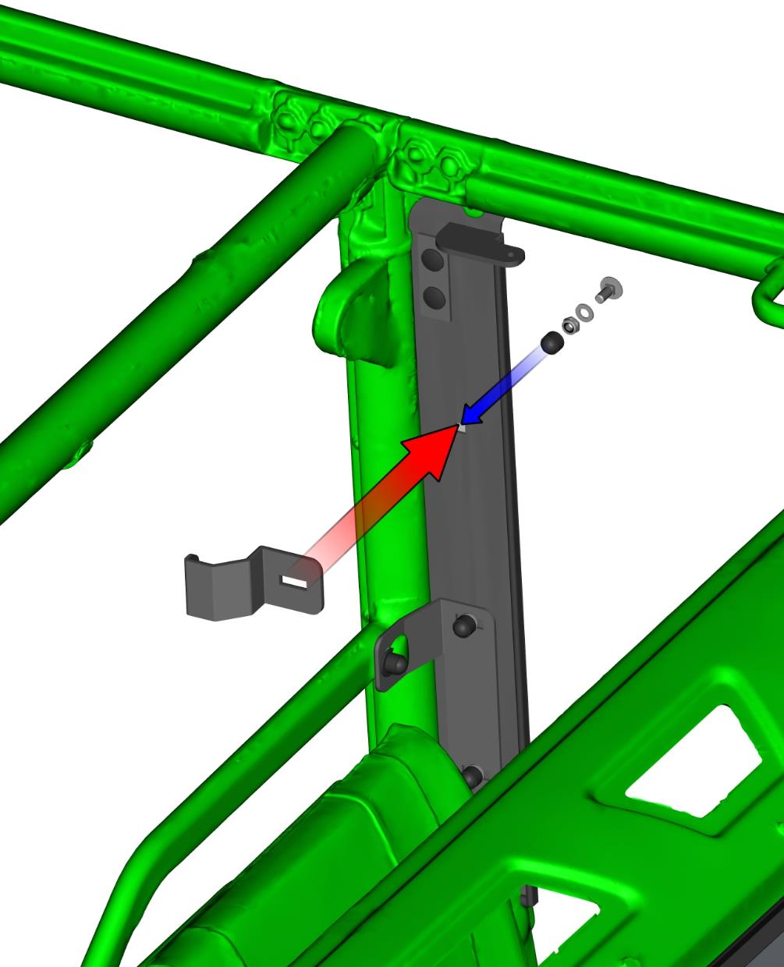
Lubricate the hinges pins and place the front left door assembly onto the door hinges.
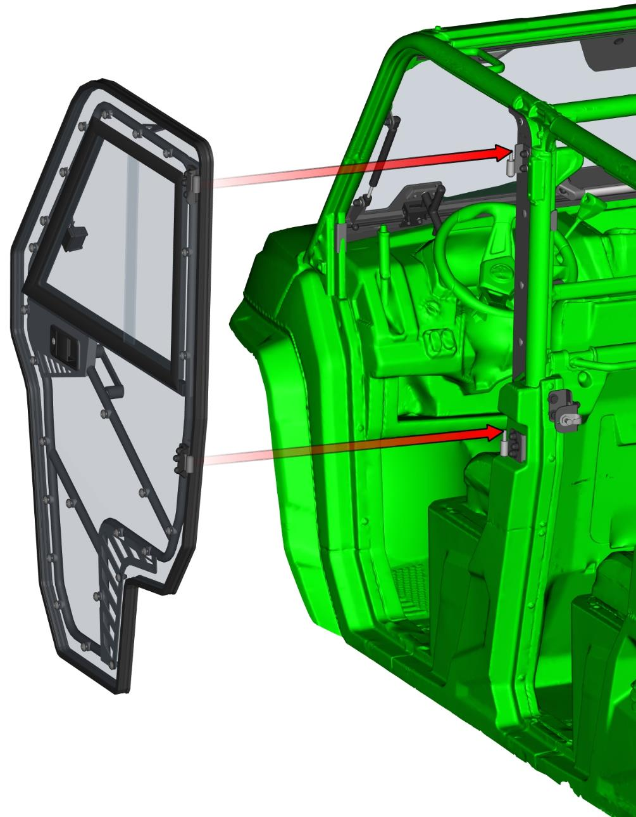
Loosen all hinge’s bolts and adjust the door into the best position in the vehicle frame and tighten hinges bolts correctly.
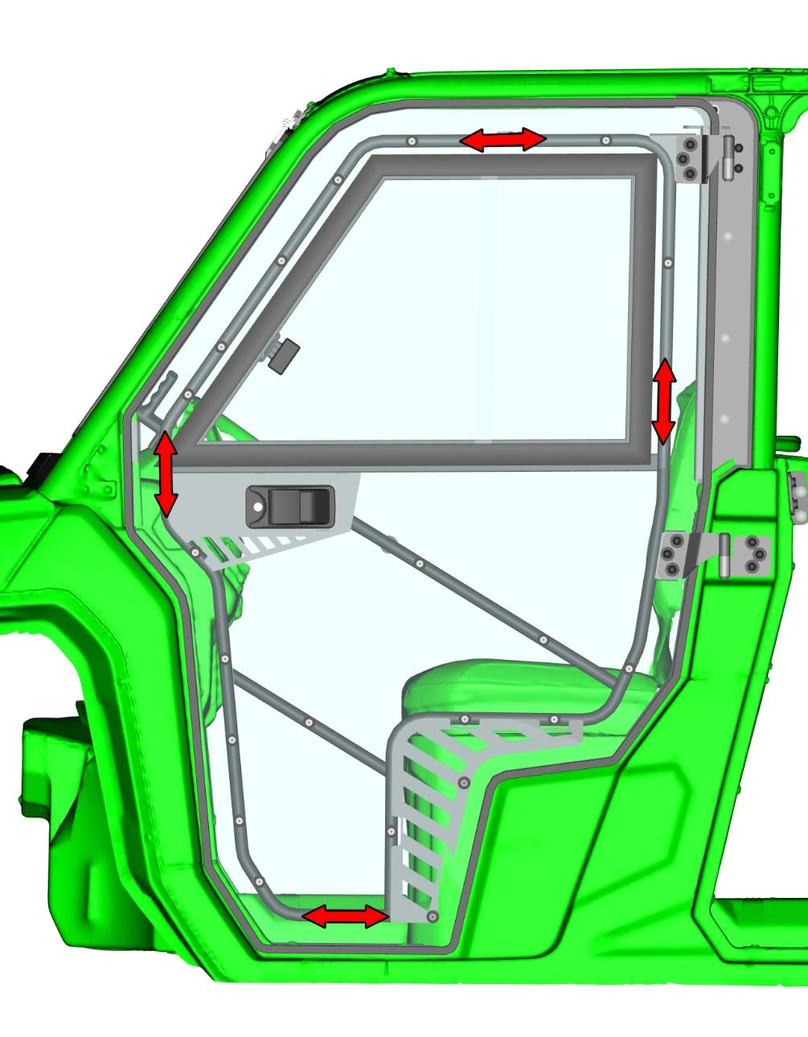
Place the left door stop assembly onto the vehicle frame.
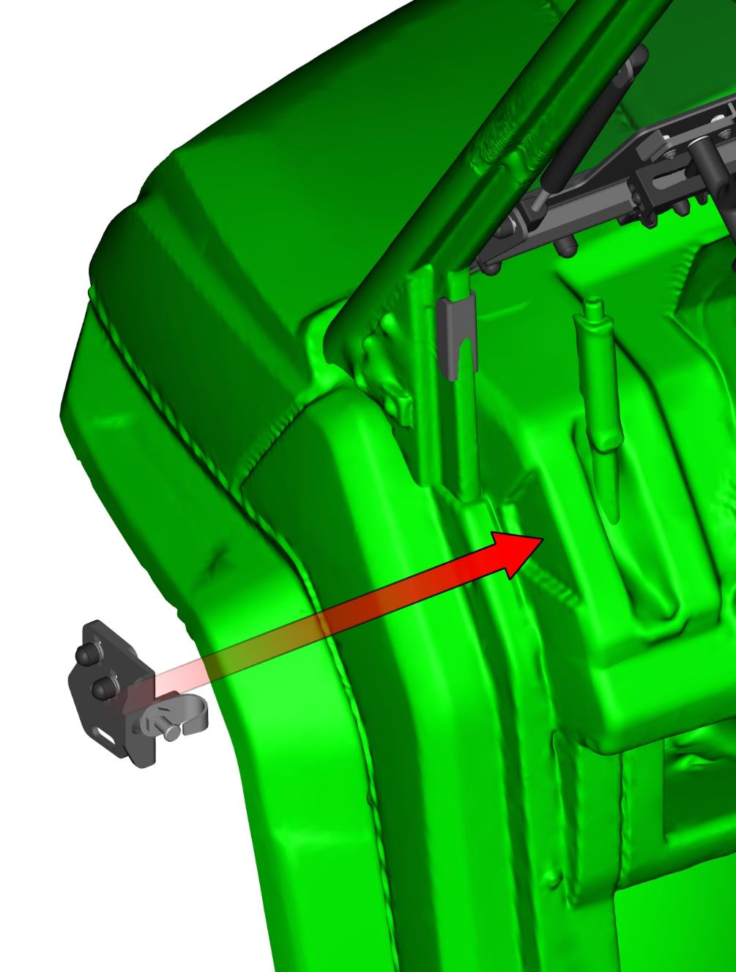
Fix the door stop assembly with the vehicle by original fixing points and included bolts and washers.
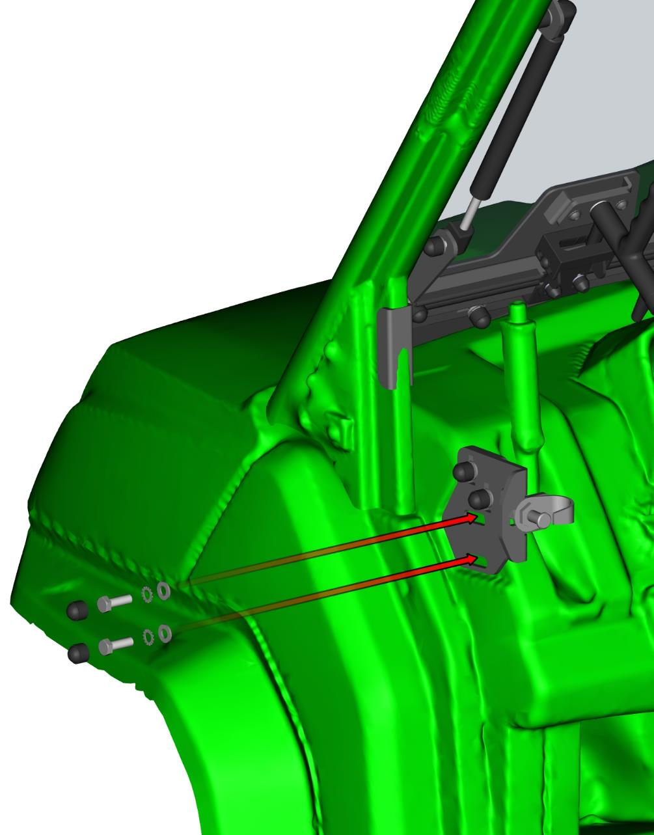
Install front gas spring pins into the gas spring holders and fix the gas spring pins by included nut, washer and cover.
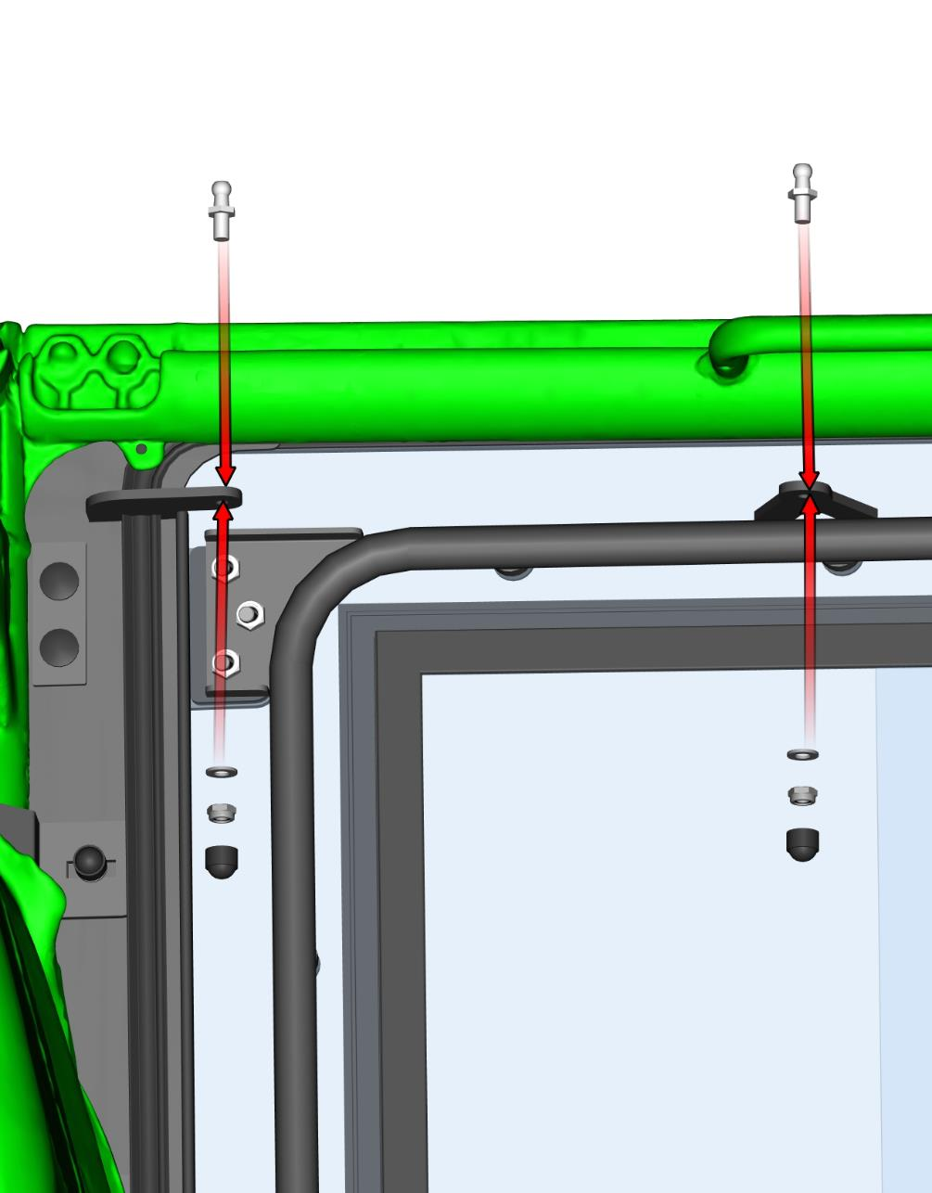
Install the gas spring onto the prepared gas spring pins. It is necessary to install gas spring in same orientation as on the picture.
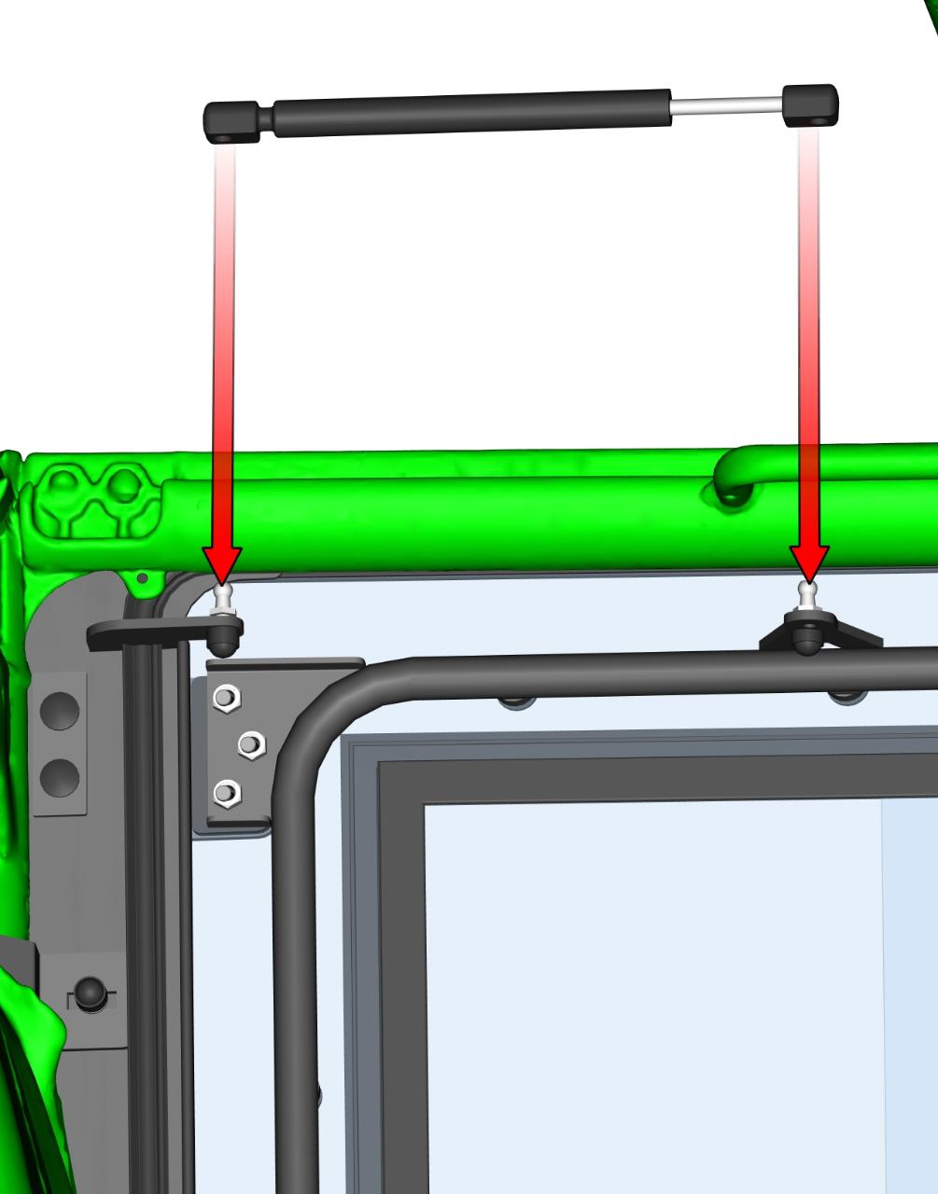
Adjust the door stop holder and door stop pin to the best position with the door. If you adjusted door pin correctly, you can hear two clear metallic clicks when you close door slowly.
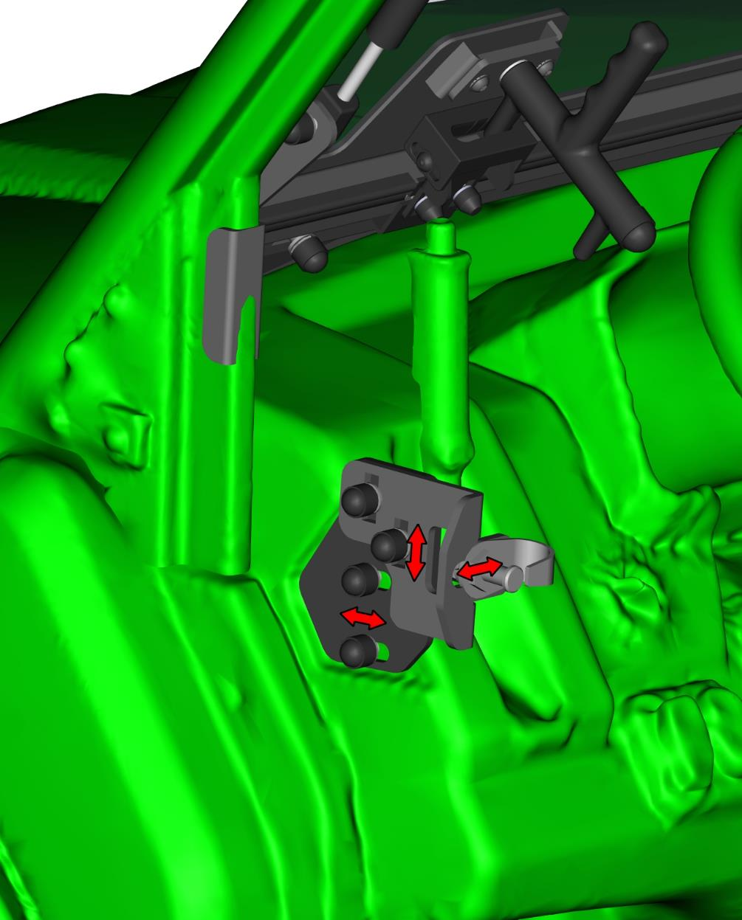
LEFT REAR DOOR + RIGHT REAR DOOR
Uninstall rear bottom original plastic cover (small cover, bolt, plastic rivets, and large cover). See next page.
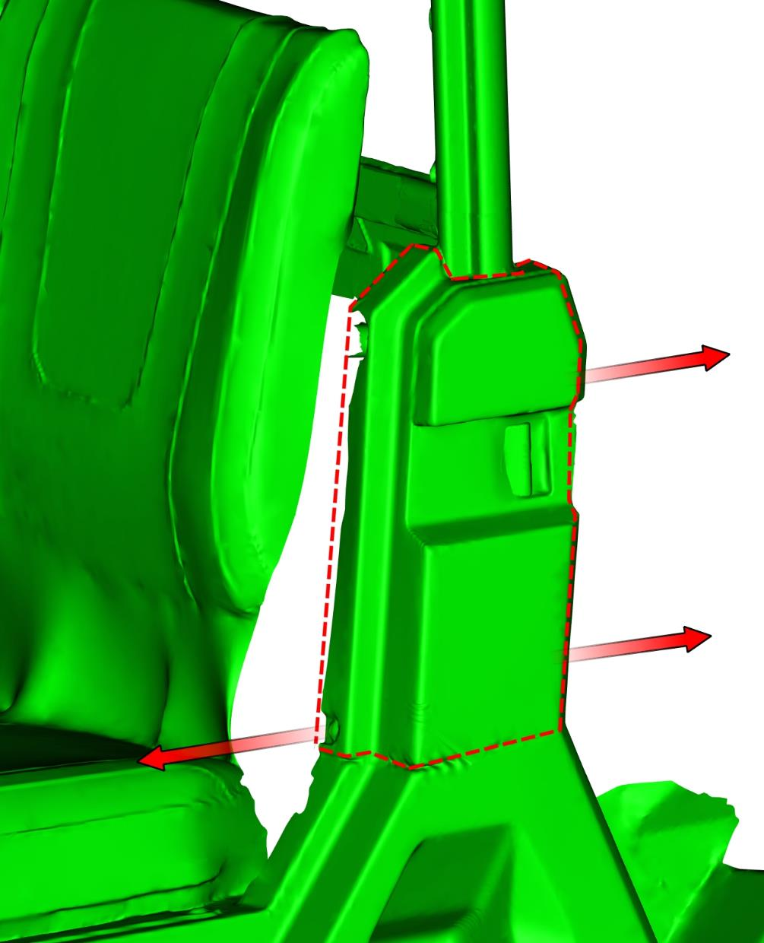
View onto the vehicle without the cover.

Place the left bottom hinge base onto the vehicle frame and fix by included bolts, washers and covers.
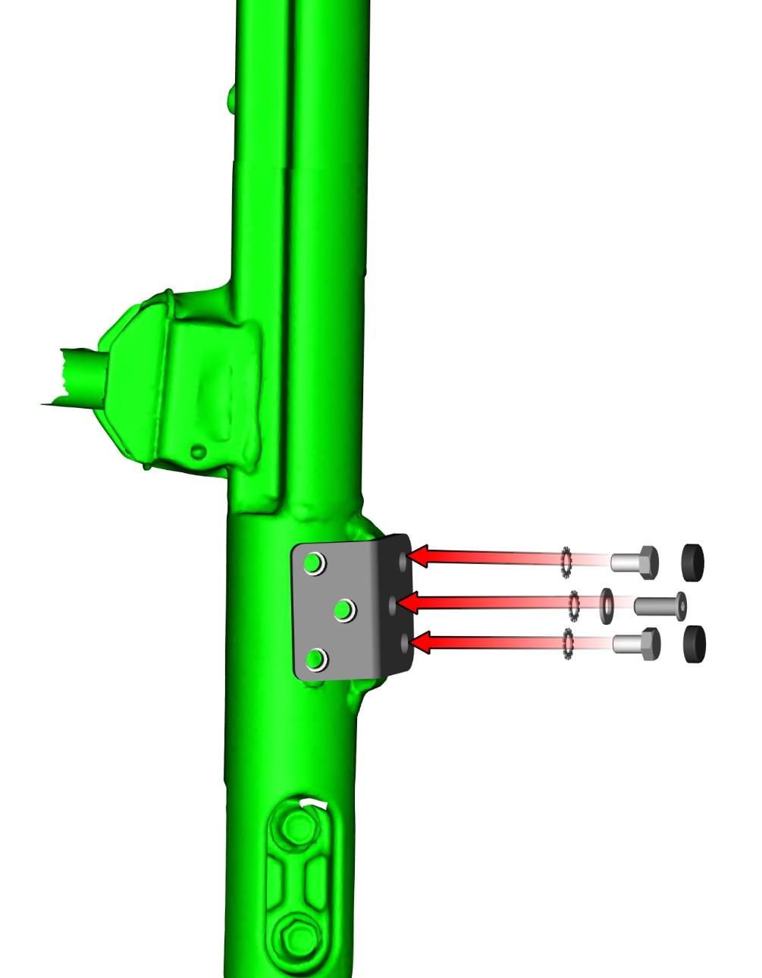
Install large plastic cover, bolt and plastic rivets back to vehicle.
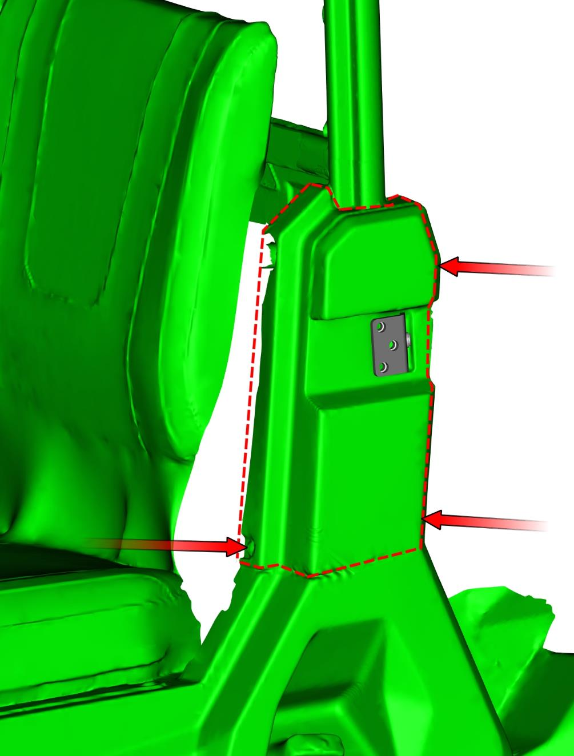
Place the left hinge onto the hinges.
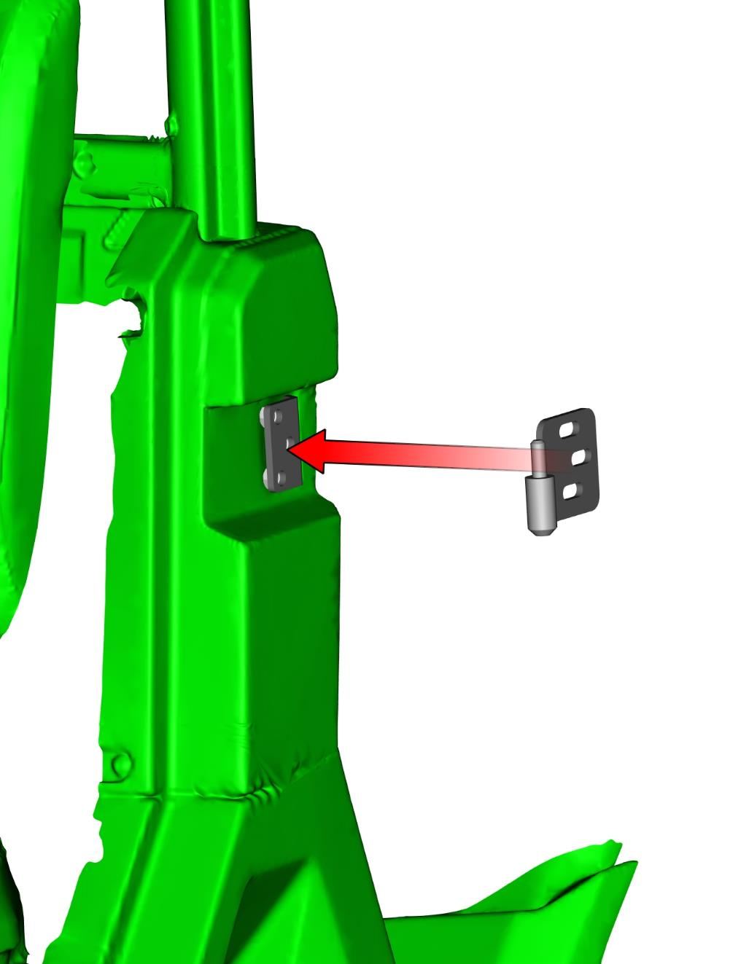
Fix the hinge by included bolts, washers and covers.
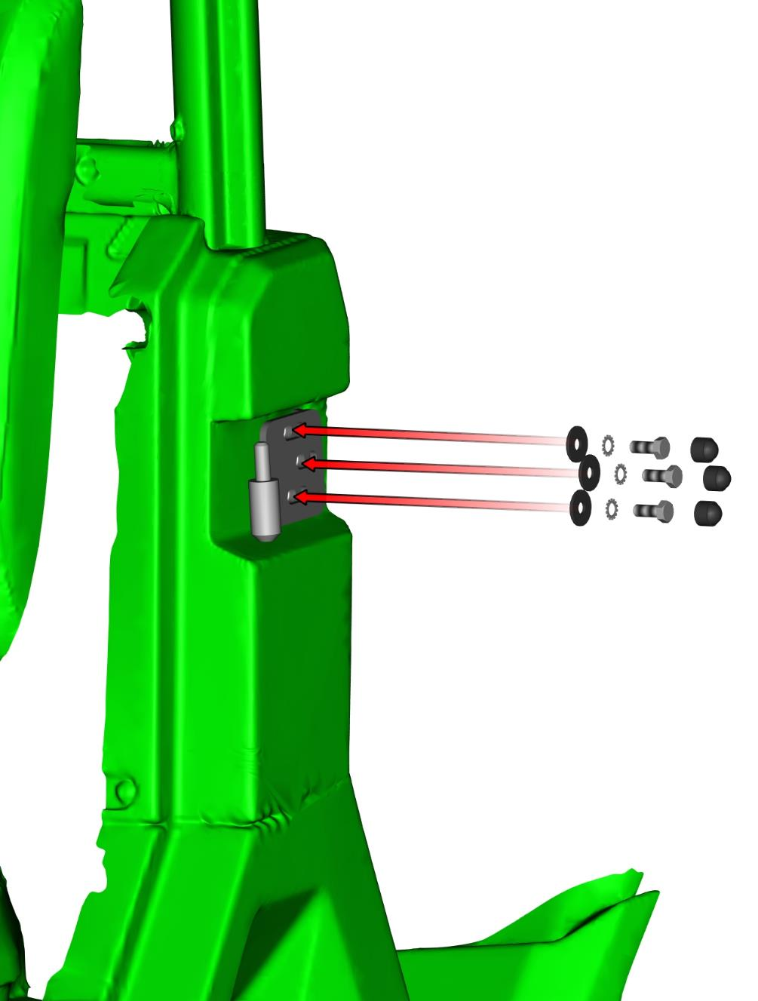
Remove the rear door base holder from the rear door base assembly.
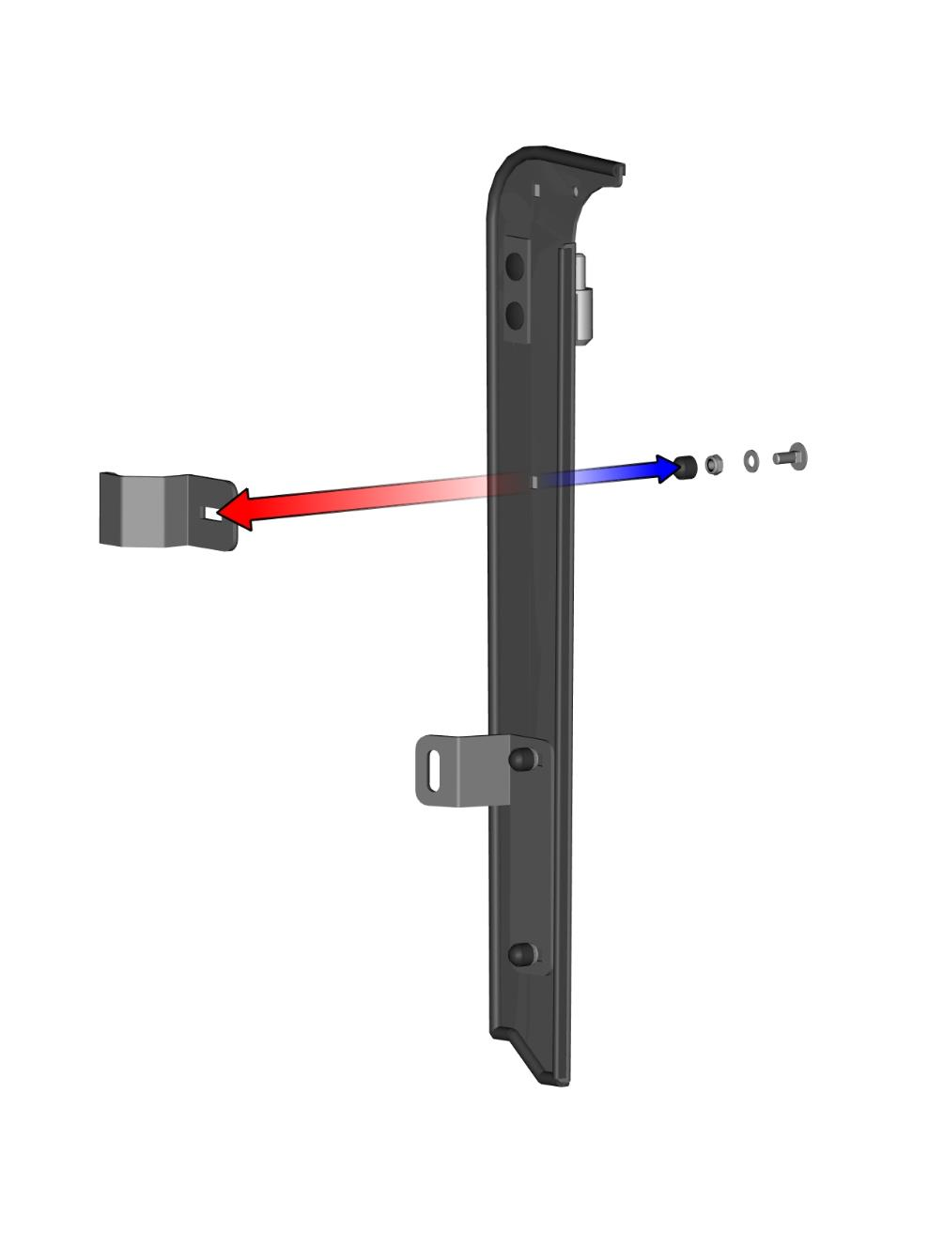
Place the rear door base assembly on the vehicle frame.
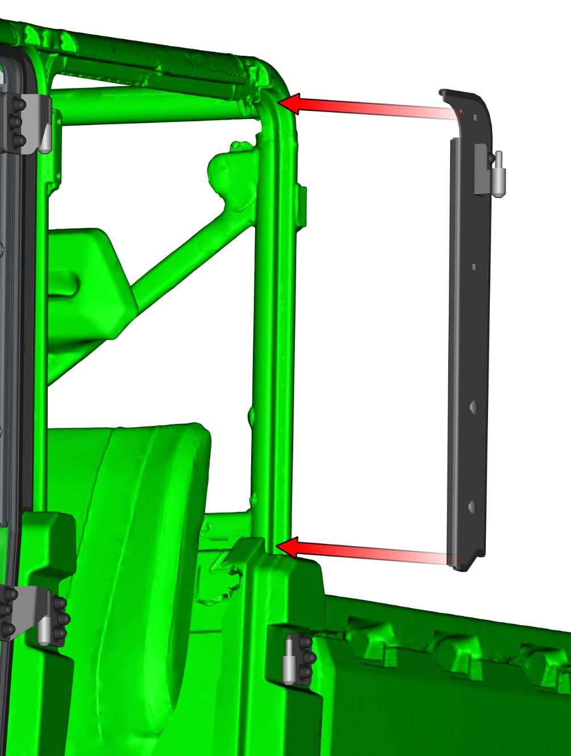
Place the upper rear door base holder onto the base and onto the vehicle frame. Fix the holder with the base to the frame by included bolt, washer, nut and cover, use original fixing point (violet mark).
Fix the holder with the base by included bolt, washer, nut and cover.
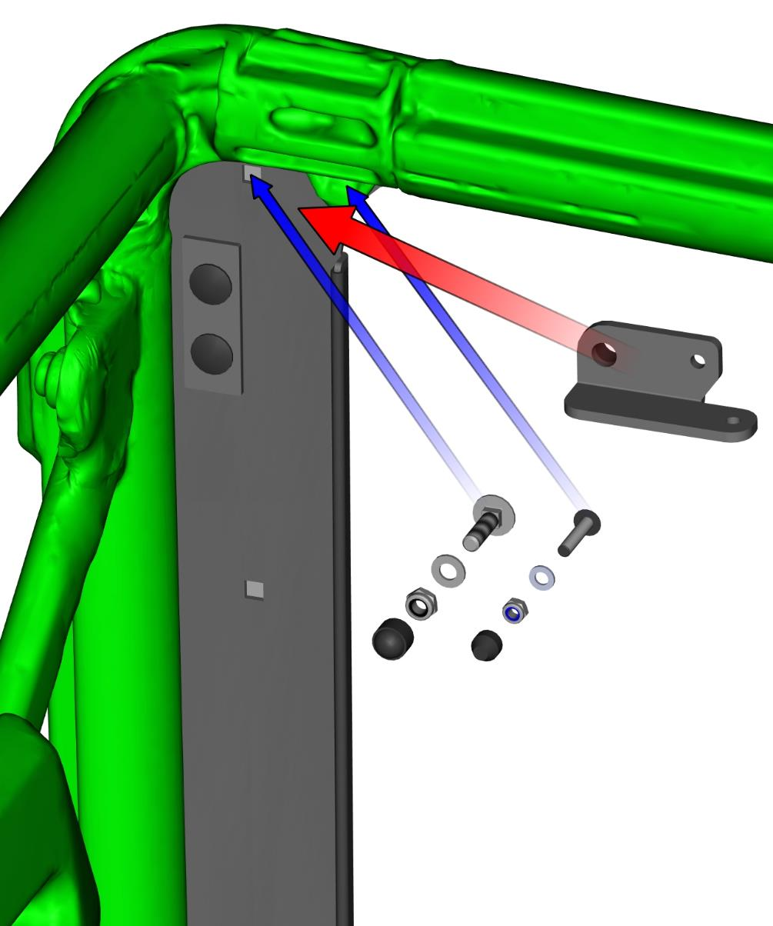
Fix the bottom rear door base holder with the vehicle frame by included bolt, washers and cover.
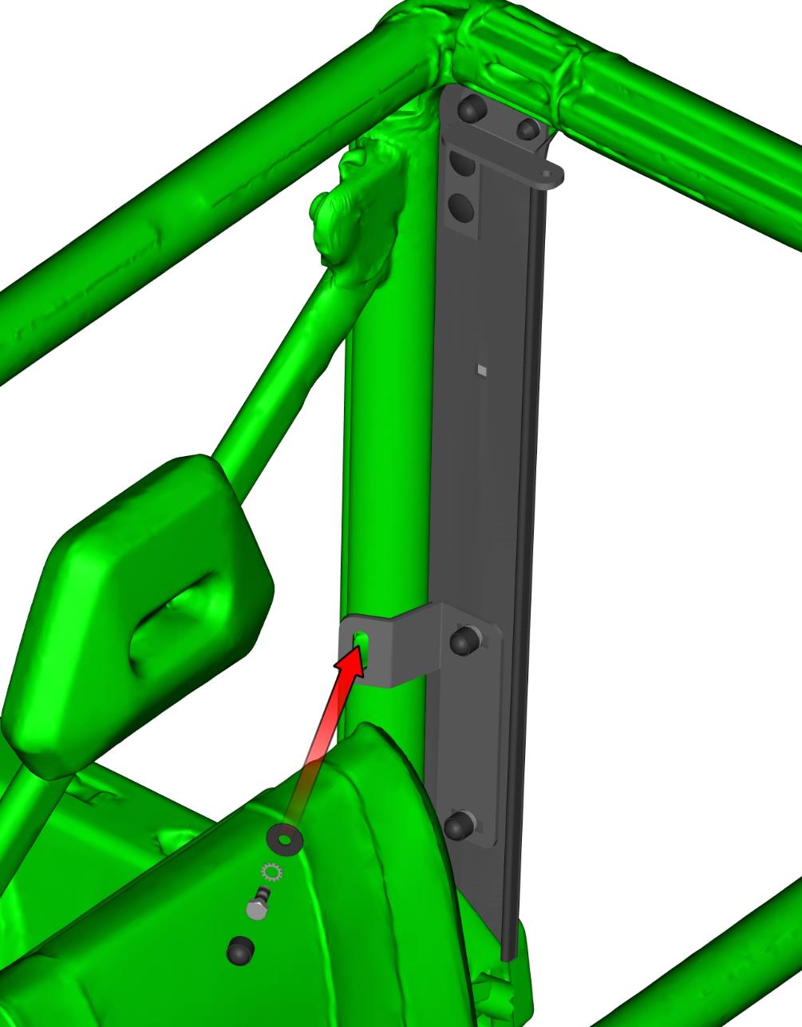
Place the rear door base upper holder onto the base and onto the vehicle frame. Fix the holder with the base to the frame by included bolt, washer, nut and cover.
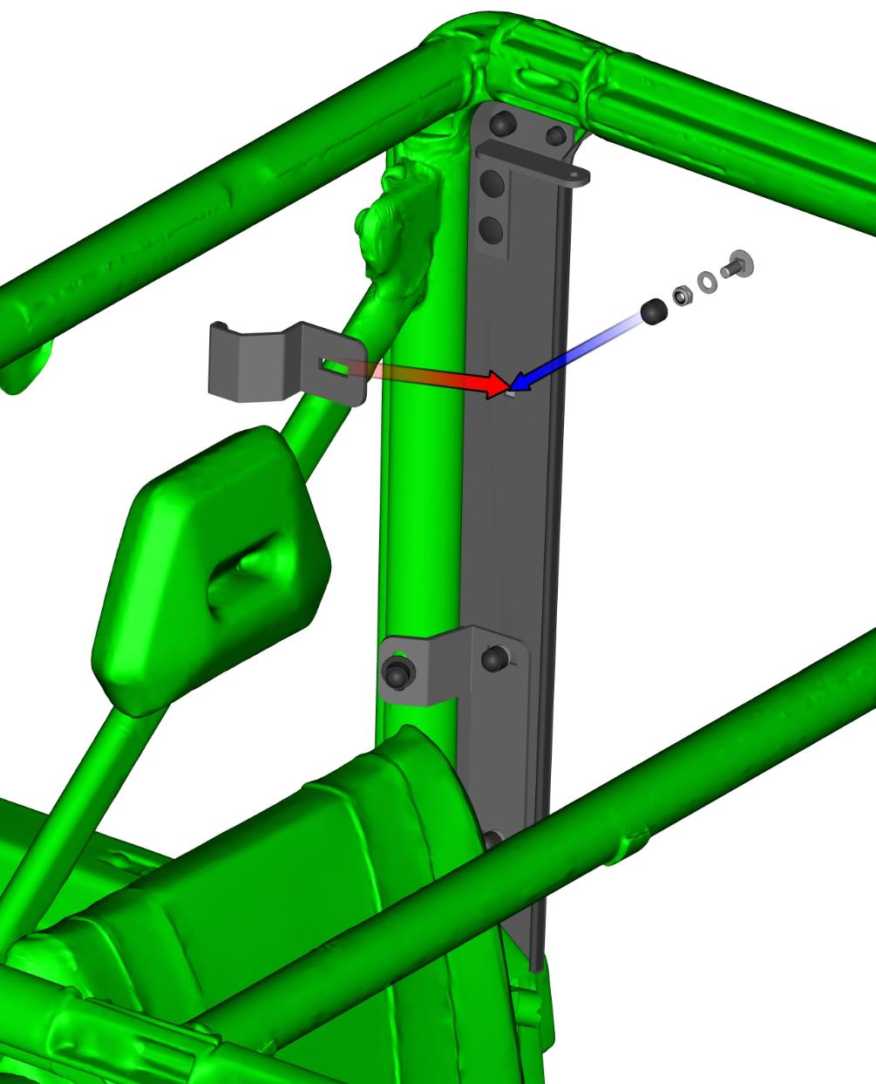
Place the rear door sealing ledge on the vehicle frame.
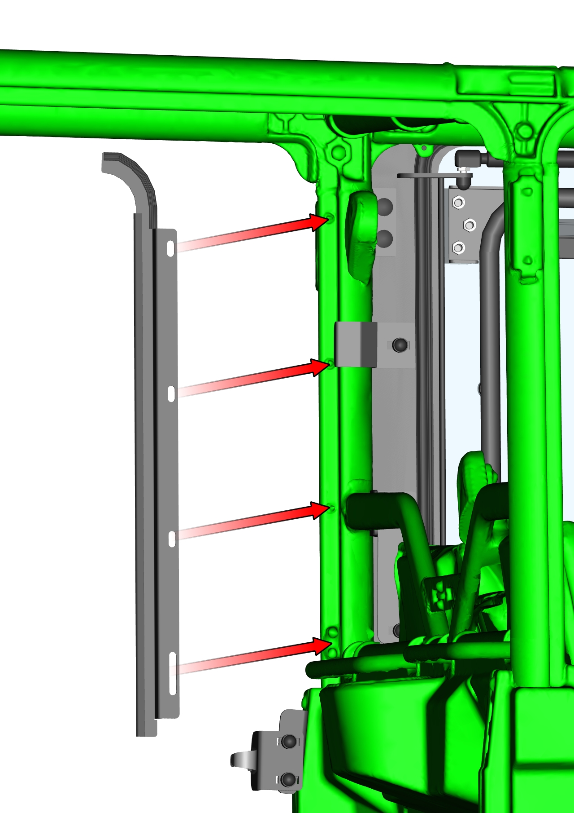
Fix the rear door sealing ledge with included screws and washers.
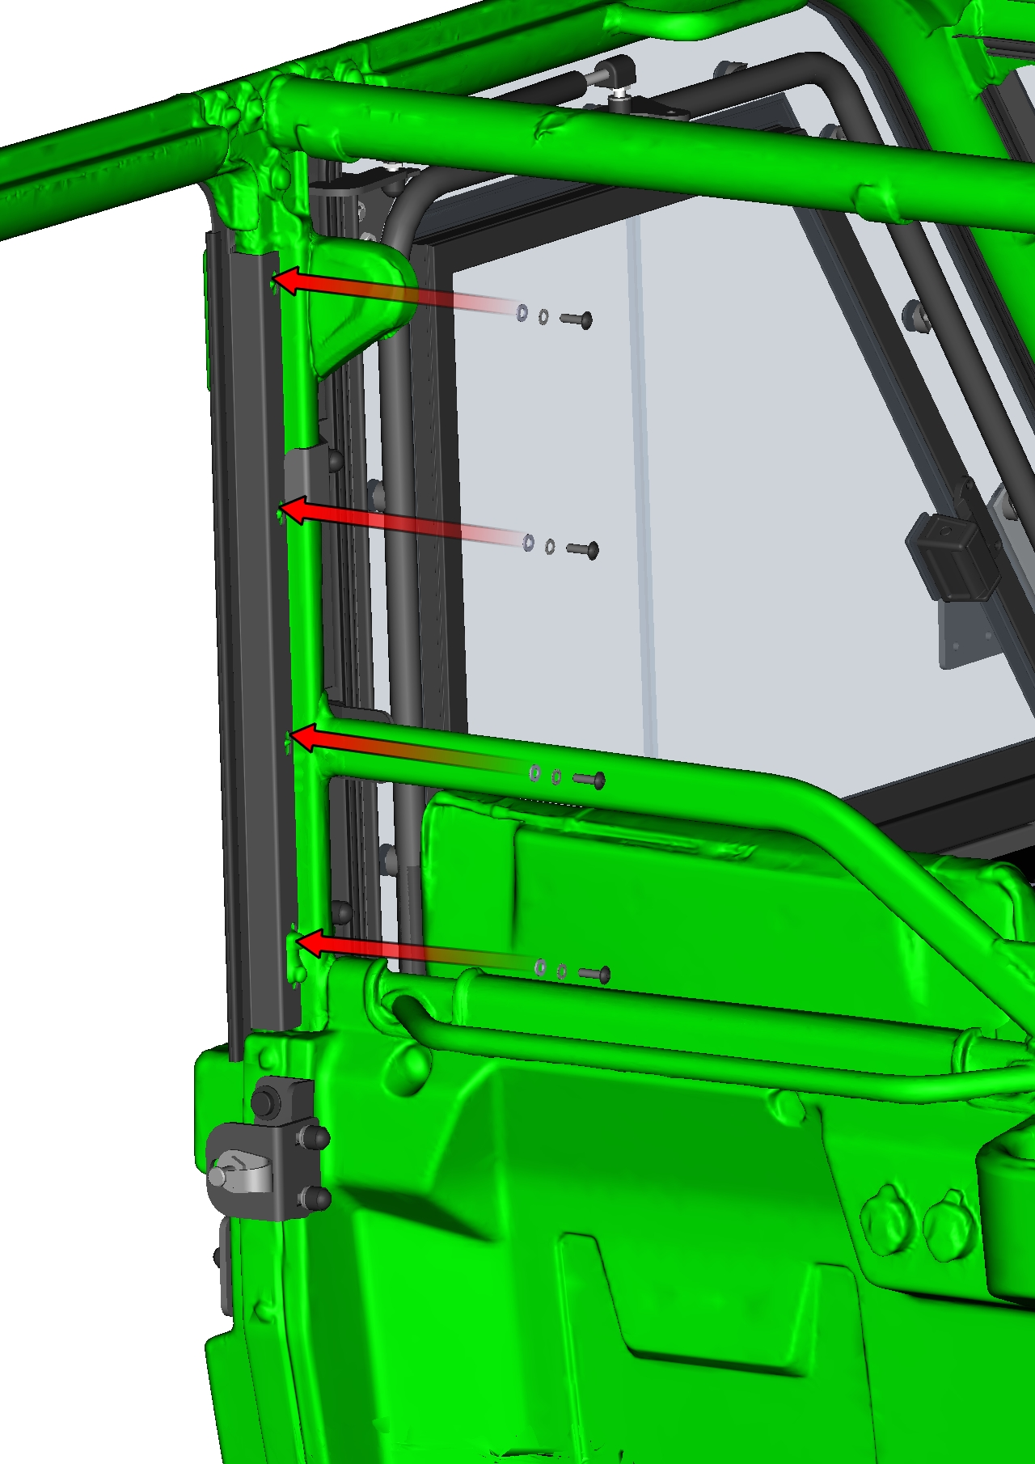
Lubricate the hinges pins and place the rear left door assembly onto the door hinges.
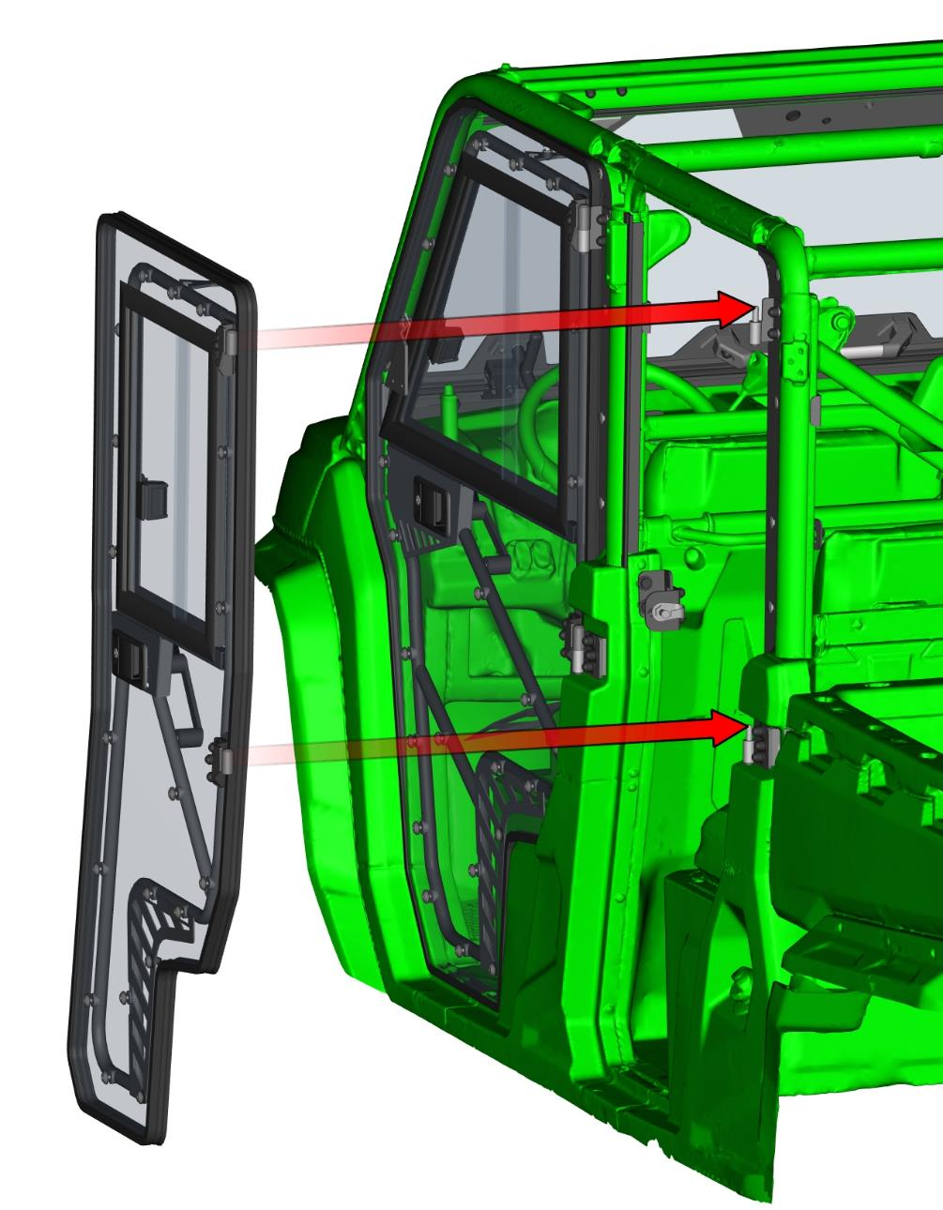
Loosen all hinge’s bolts and adjust the door into the best position in the vehicle frame and tighten hinges bolts correctly.
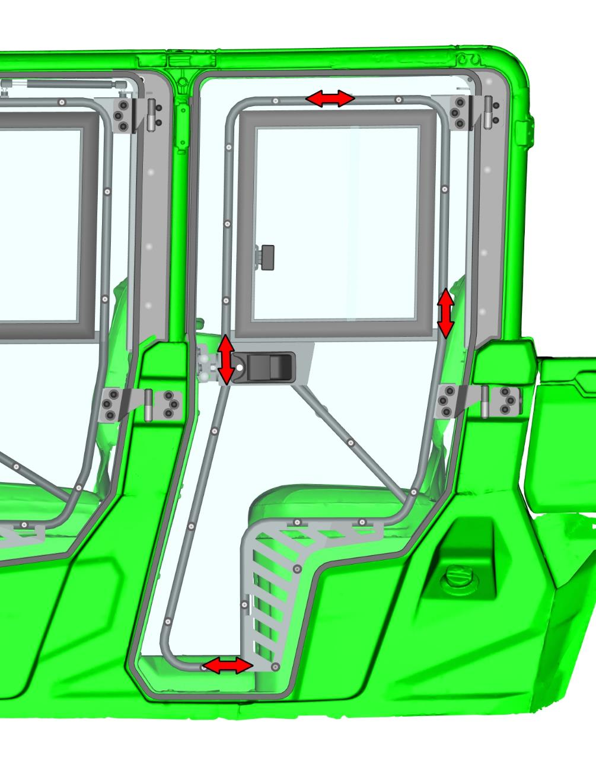
Install rear gas spring pins into the gas spring holders and fix the gas spring pins by included nut, washer and cover.
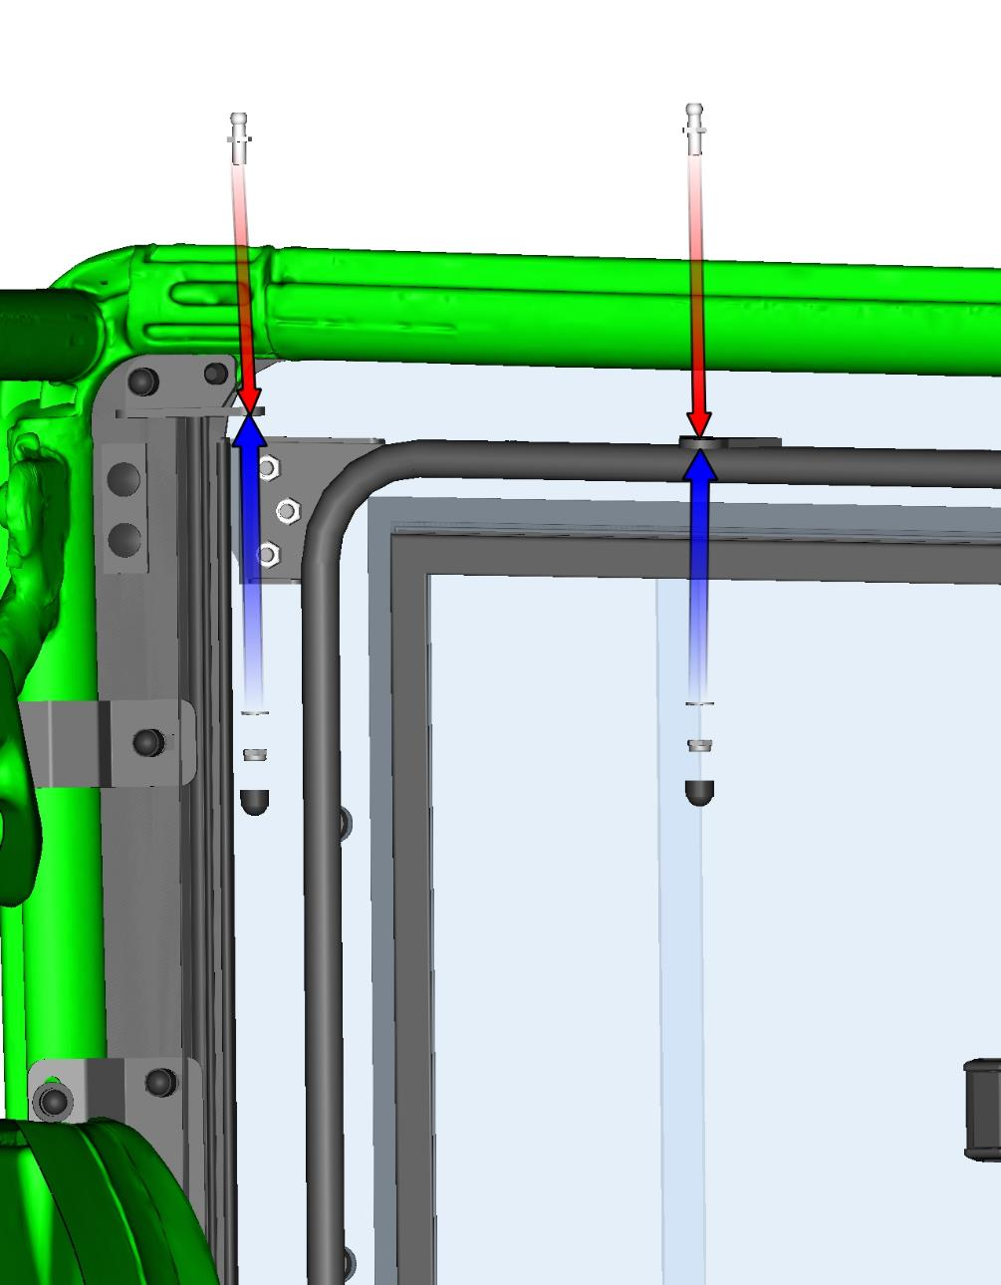
Install the gas spring onto the prepared gas spring pins. It is necessary to install gas spring in same orientation as on the picture.
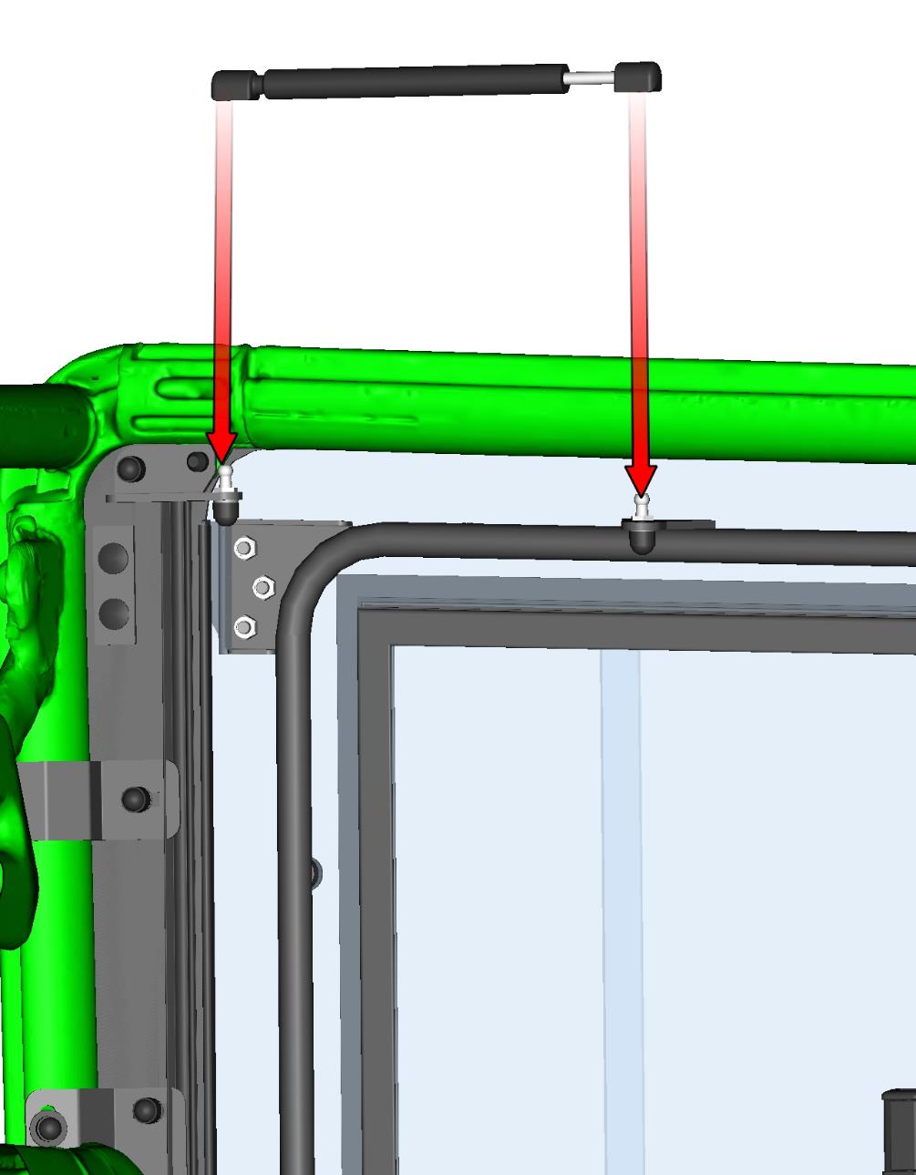
Adjust the door stop holder and door stop pin to the best position with the door. If you adjusted door pin correctly, you can hear two clear metallic clicks when you close door slowly.
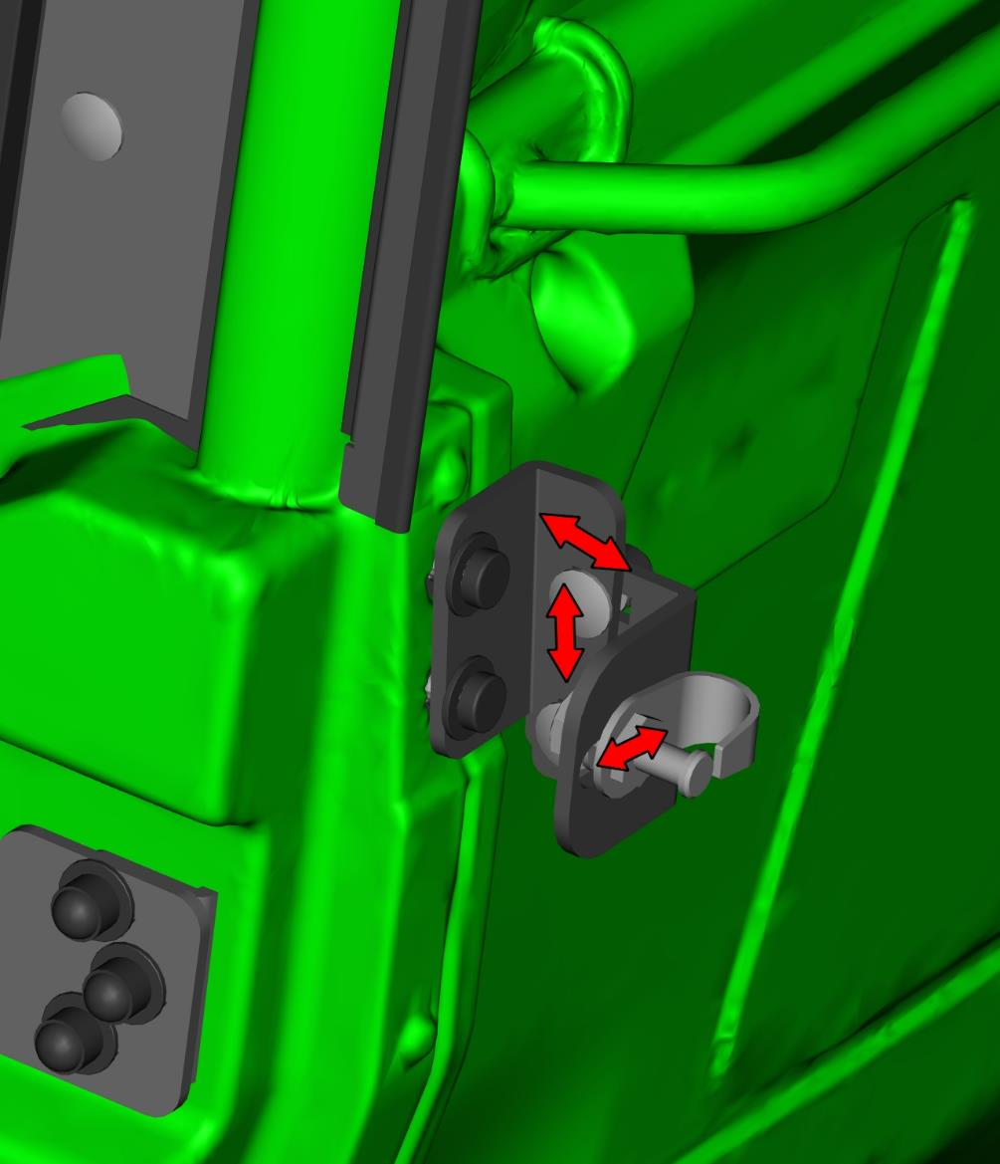

Repeat previous steps on the vehicle right side with the right door assemblies.
ROOF
Degrease the surface of the vehicle frame where the sealing will be affixed. (red line)
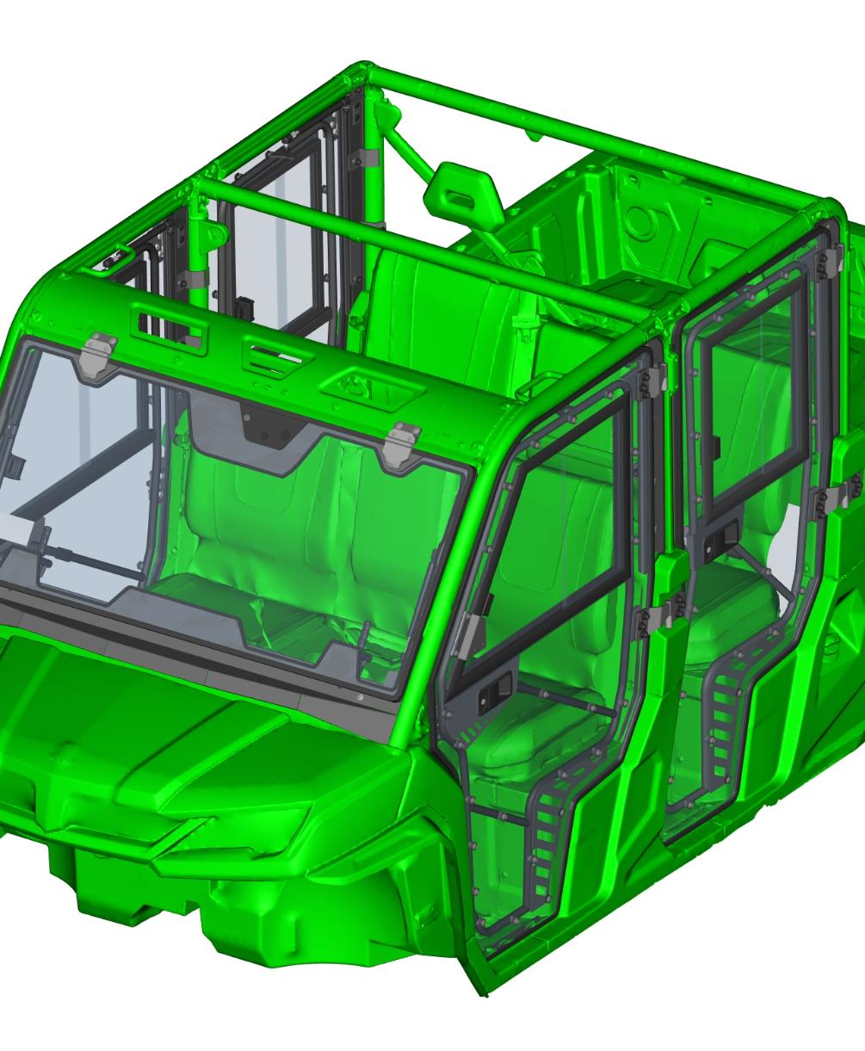
Stick the self glutes sealing Apolo on the vehicle frame as shown below. Cut the seal to the required length.

Apolo sealing profile.
Stick the self glutes sealing KR on the vehicle frame as shown below. Cut the seal to the required length.

KR sealing profile.
Stick the self glutes sealing KR on the other side of the vehicle frame as shown below. Cut the seal to the required length.

Degrease the surface of the vehicle frame where the sealing sticker will be affixed. Stick the sealing sticker on the vehicle frame as shown below.
Degrease the surface of the vehicle frame where the sealing sticker will be affixed. Stick the sealing sticker on the vehicle frame on the other side as shown below.
Place the original plastic roof back on vehicle. Fix the roof with original fixing assemblies.
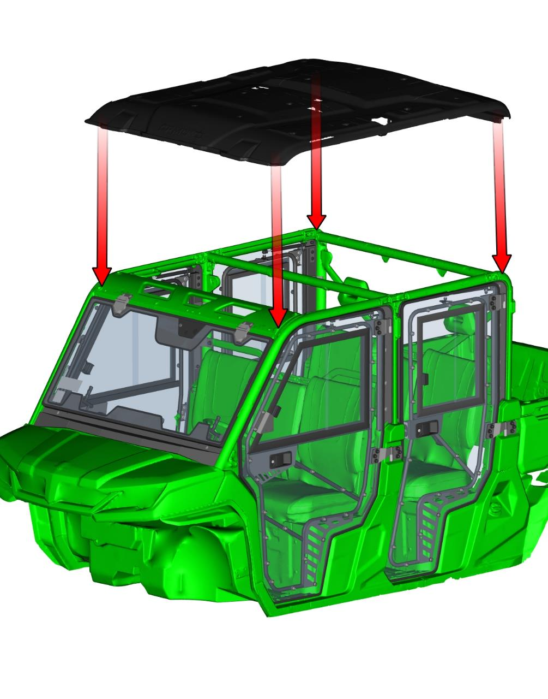
REAR PANEL
Loose the rear holder bolts and turn holders to neutral position.
Place the rear assembly onto the vehicle frame and onto the roof.
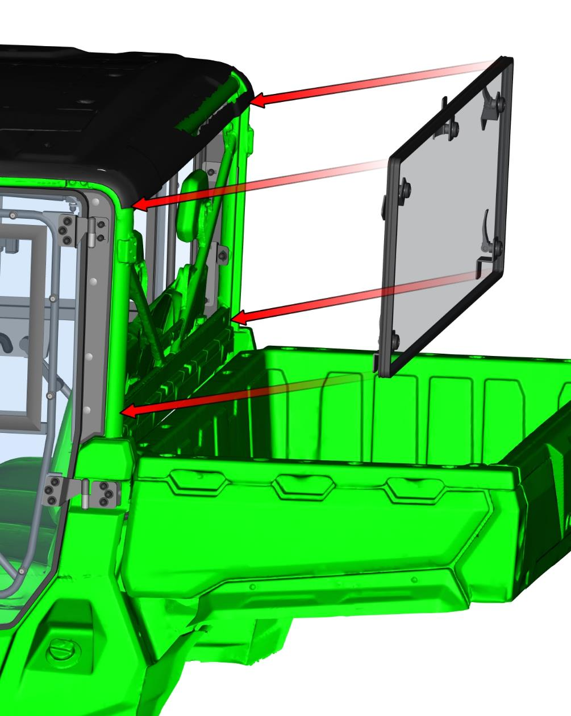
Turn holders to the best position and tighten holder bolts correctly.
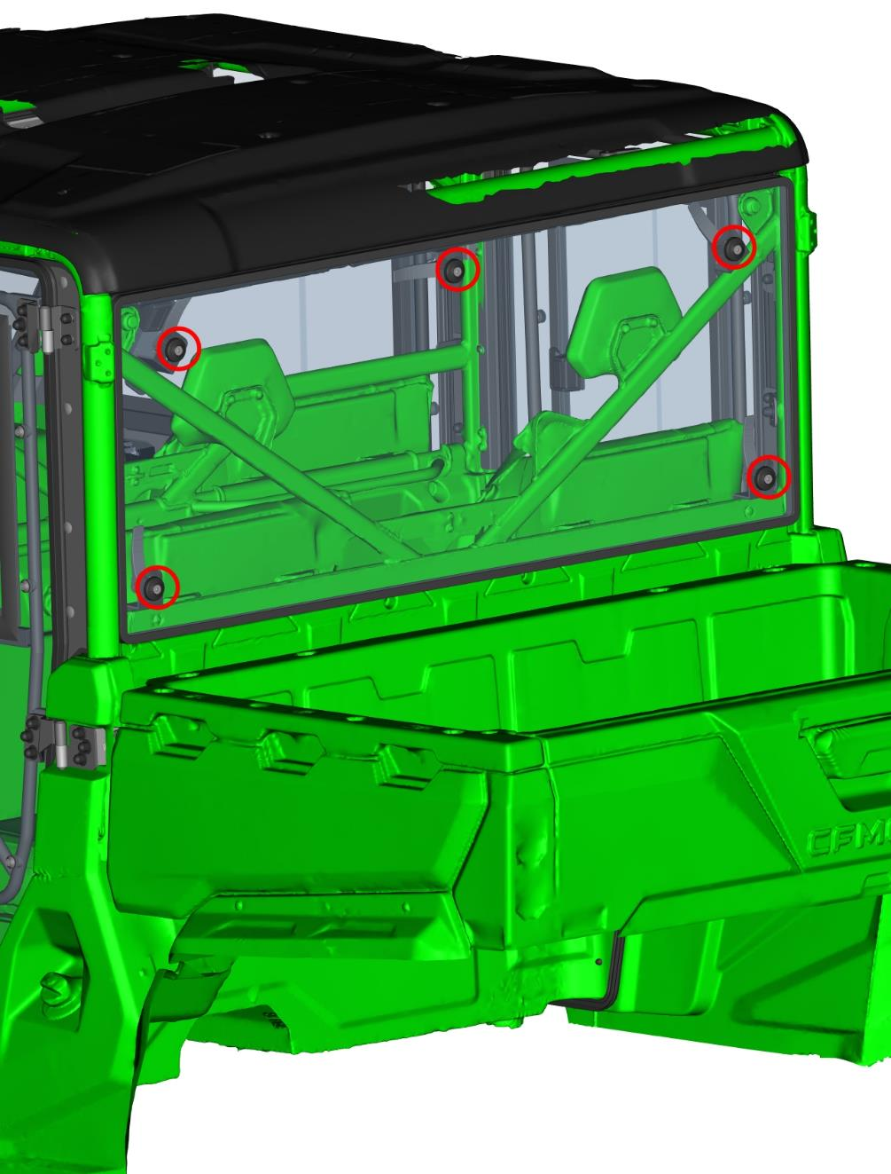
ORIGINAL SIDE MIRROR
Only if you have original side mirrors.
If you have door mirror holders installed, you can skip to next page.
Uninstall door bolts and washers. Place the left side mirror holder onto the door and fix by bolts and washers from previous step.
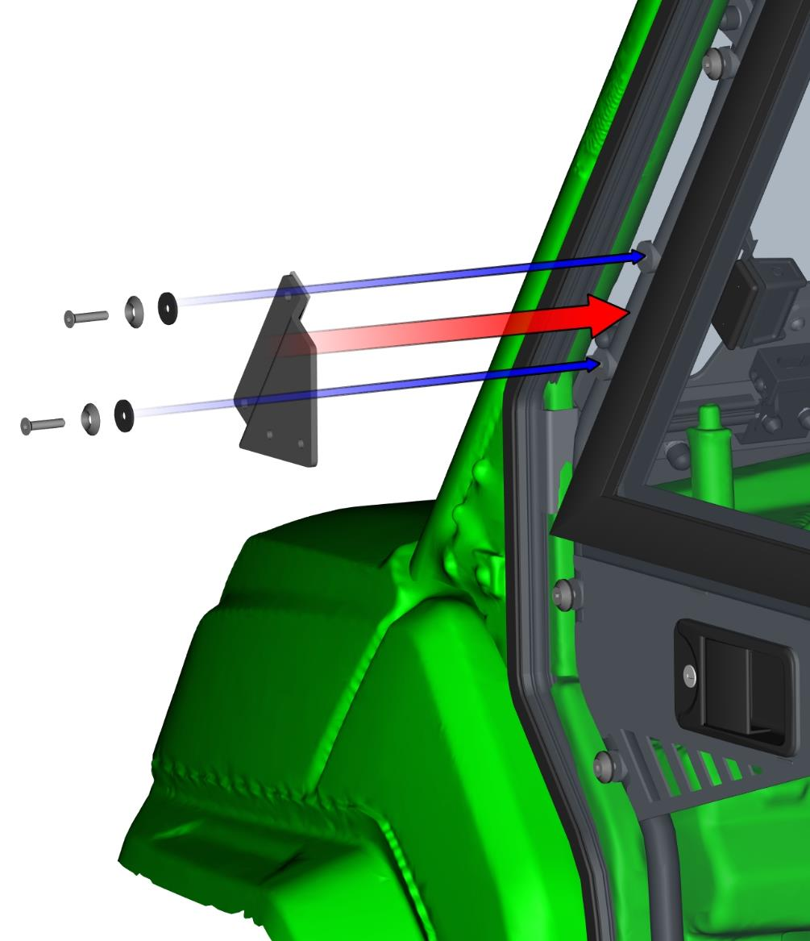
Install the original rear view mirror onto the holder by original bolts.

Repeat previous steps on the right side with the right assemblies.

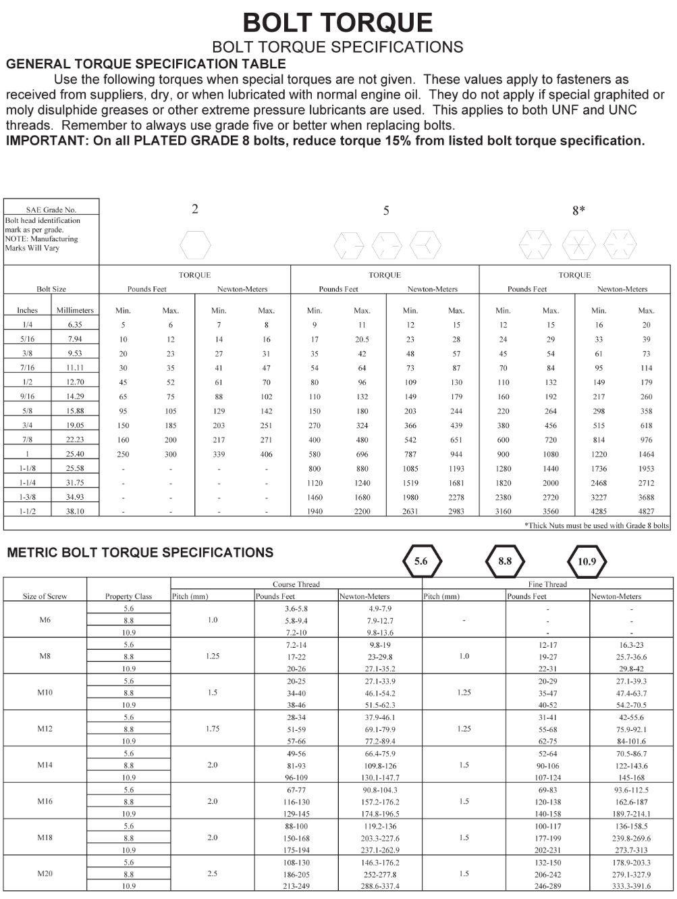

Declaration of Conformity



DFK Cab, s.r.o.
Za Olšávkou 391
686 01 Uherské Hradiště
Česká republika / Czech Republic

